Neutral Citation Number: [2021] EWHC 732 (IPEC)
Case No: IP-2018-000199
IN THE HIGH COURT OF JUSTICE
BUSINESS AND PROPERTY COURTS OF ENGLAND AND WALES
INTELLECTUAL PROPERTY ENTERPRISE COURT

Royal Courts of Justice, Rolls Building
Fetter Lane, London, EC4A 1NL

Date: 25/03/2021

Before :

HIS HONOUR JUDGE HACON
- - - - - - - - - - - - - - - - - - - - -
Between :

 | KWIKBOLT LIMITED | Claimant
 | - and -
 | AIRBUS OPERATIONS LIMITED | Defendant

- - - - - - - - - - - - - - - - - - - - -
- - - - - - - - - - - - - - - - - - - - -

Mark Vanhegan QC and Heather Lawrence (instructed by Williams Powell) for the Claimant
Henry Ward (instructed by Allen & Overy LLP) for the Defendant

Hearing dates: 9-12 February 2021
- - - - - - - - - - - - - - - - - - - - -

Approved Judgment
Covid-19 Protocol: This judgment was handed down remotely by circulation to the parties’ representatives by email and release to BAILII. The date and time for hand-down is deemed to be 10.30 a.m. on Thursday 25 March 2021.
.............................

HIS HONOUR JUDGE HACON

Judge Hacon :

Introduction
- The Claimant (“Kwikbolt”) is a small company in the business of designing and making fasteners used in the aerospace and defence industries. It is the proprietor of UK Patent No. GB2455635B (“the Patent”) which claims an invention entitled “Removeable blind fastener”. “Blind” is a term of art in the context of fasteners, meaning that the fastener can be fitted from one side of the workpiece, essential if the technician only has access to one side. I will later say more about “removeable”.
- The Defendant (“Airbus”) is the well-known aircraft manufacturer.
- Some of Airbus’s assembly lines use removable blind fasteners made by Centrix Inc (“Centrix”), a manufacturer of aerospace products. More specifically, Airbus uses a product called the Centrix Free Spin Fastener (“the Centrix Fastener”) in the assembly of A320 and A350 wings at Broughton in North Wales.
- Kwikbolt alleges that the use and keeping of Centrix Fasteners by Airbus has infringed the Patent. Airbus counterclaims, alleging that the Patent is invalid for lack of novelty, lack of inventive step and insufficiency.
- Mr Mark Vanhegan QC and Dr Heather Lawrence appeared for Kwikbolt, Mr Henry Ward for Airbus.

The Evidence of Travis McClure
- Travis McClure was Airbus’s witness of fact. He is the Chief Executive Officer at Centrix. Mr McClure’s evidence should have been limited to a short point. Airbus relied on an allegation of prior use of the invention by reason of the marketing of a fastener called the “E-Nut”. At the CMC Airbus was given permission to file evidence from a witness of fact to deal with the question whether the E-Nut was publicly available before the priority date. Mr McClure gave evidence about that issue.
- In its skeleton argument for trial, Kwikbolt admitted that the E-Nut had been publicly available before the priority date. It was argued in the skeleton that this issue therefore fell away and that Mr McClure’s evidence as a whole should be disregarded.
- There was a lot of force in that. My reservation was that among the more expansive sections of Mr McClure’s evidence, he had challenged assertions of fact made by Mr McKay about the E-Nut. The E-Nut was referred to by both experts in their reports by way of discussion of the common general knowledge. I was persuaded at the start of the trial that unless at least those parts of Mr McClure’s witness statement remained in evidence, the balance of evidence regarding the structure and extent of use of the E-Nut might be unfairly skewed in Kwikbolt’s favour. I allowed his witness statement to remain in evidence and invited Mr Vanhegan to cross-examine Mr McClure to the extent that he believed any of McClure’s evidence still to be relevant.
- This led to the next bone of contention. It concerned Kwikbolt’s use of a bundle of documents for the cross-examination of Mr McClure. I was told that this was not served until the morning of the cross-examination.
- Mr Ward referred to the Patents Court Guide which contains the following paragraph:

“14.9 Where any party wishes to put documents to a witness in cross-examination, these should generally be supplied to the witness sufficient time in advance so that the witness has time to consider them before giving evidence. Generally, documents for cross- examination should be supplied at least 48 hours before the witness gives evidence. However, more time may be required depending on the nature and number of the documents intended to be relied upon. The number of documents should be kept within manageable bounds. In the case of documents over 4 pages long, there should be an indication of which parts will be put to the witness.”
- Mr Vanhegan protested that paragraph 14.9 applies only to experts. I see nothing in its wording to confine its application in that way.
- There is no equivalent rule in the IPEC Guide because the use of documents in an IPEC trial is governed by the more general provision contained in CPR 62.23(2): save in exceptional circumstances the court will not permit a party to submit material in addition to that ordered in the CMC.
- It is sometimes helpful for the court and the witness to have new documents put in cross-examination, such as a diagrammatic illustration of a process or some other document that simplifies and speeds the giving of evidence, particularly where the content of the document is familiar to the witness. There can be other types of exceptional case in which the court will allow the use of new documents in cross-examination even if the contents are new.
- When the use of Kwikbolt’s bundle was challenged in the course of Mr McClure’s cross-examination, I told Mr Ward that I would allow Mr Vanhegan to put questions by reference to these documents but that I would be very receptive to any argument that either the witness or Mr Ward had not had the opportunity to investigate the document in question, adding that if this were the case I may well disallow the question.
- Only a few pages from the bundle were put to Mr McClure. Mr Ward raised no objection to any of them so the cross-examination went ahead uninterrupted on that score. In Mr Ward’s written closing submissions, however, he repeated his objection to the bundle, again criticising its very late service. Mr Vanhegan gave me no direct answer when asked why the bundle had been served at such short notice.
- For the most part Mr McClure was a good witness, giving clear answers without prevarication. The exceptions were his answers to questions put by reference to the few documents selected from the cross-examination bundle. I do not draw any conclusion from those answers about Mr McClure as a witness or otherwise. The short point is that none of Mr McClure’s evidence proved to be relevant to anything I have to decide.
- However, litigants should be aware that in this court any party intending to rely on a cross-examination bundle should give the witness adequate notice of the bundle, which will normally be at least 48 hours, and should inform both the court and the opposing side of the exceptional reasons which justify the late introduction of new documents into the case.

The Experts

Douglas McKay
- Kwikbolt’s expert was Douglas McKay. Mr McKay worked in the aircraft manufacturing industry for 27 years from 1988 until his retirement in 2015. He held positions as an engineer successively in three Texan corporations, from 1998 in the aerospace industry, first at Vought Aircraft Industries Inc and from 2005 at Lockheed Martin Aeronautics Company. One of Mr McKay’s tasks at Lockheed was leading efforts to identify and develop a more suitable temporary fastener for use on F-35 wing assembly lines.
- Mr Ward, counsel for Airbus, could not have been more approving of Mr McKay as a witness in cross-examination, describing him as a completely straightforward witness, very knowledgeable, doing his best to help the court. I agree. The sting in the tail of Mr Ward’s submission was that by contrast Mr McKay’s reports were full of factual inaccuracies, some corrected after the relevant report had been sworn and others not, and that Mr McKay had in cross-examination abandoned every important proposition made in his report in relation to the Patent and the prior art. Mr Ward said that Mr McKay’s reports had been prepared in a way that did not reflect his honest views and should be treated with the highest degree of scepticism. Before commenting on this I will discuss Mr Jack’s evidence.

Milton Jack
- Milton Jack was Airbus’s expert. His career was spent mostly as an employee of The Boeing Company, working as an engineering technician. He began at Boeing in 1966 and retired from that company in 2002. There was a break from Boeing between 1970 and 1977, during which Mr Jack spent time at the Lockheed Aircraft Corporation, North American Rockwell, the Northrop Corporation and Mitsubishi Heavy Industries. After he retired as an employee, Mr Jack founded his own consulting company, OMT Inc (he said that it stood for Old Man’s Thoughts), through which he provided consultancy services to Boeing. Throughout his career Mr Jack worked with temporary and permanent fasteners used in the aerospace industry.
- Mr Vanhegan’s submissions on Mr Jack as a witness mirrored those of Mr Ward on Mr McKay: he was a good witness in cross-examination doing his best to help the court, but his report was not satisfactory. Each legal team was, by implication, accusing the other of having an overbearing influence on its expert.
- I agree in full with the commendation of both Mr McKay’s and Mr Jack’s conduct in cross-examination. Both experts gave honest and helpful evidence. However, I think it is possible that the preparation of each of their respective reports was steered by the relevant legal team with an excessively firm hand on the wheel. More than is usual, the evidence given in cross-examination by the experts was likely to be more reliable than that given in a report.

The Patent
- The Patent has a filing date of 1 February 2008 and no priority date. The specification begins with an inaccurate statement of the problem which the invention is said to solve: the need for a temporary fastener. Temporary fasteners were by common consent well known at the filing date.
- The figures of the Patent illustrate an embodiment by which the invention as a whole is most easily understood. This is Figure 1 with added labelling in upper case script:

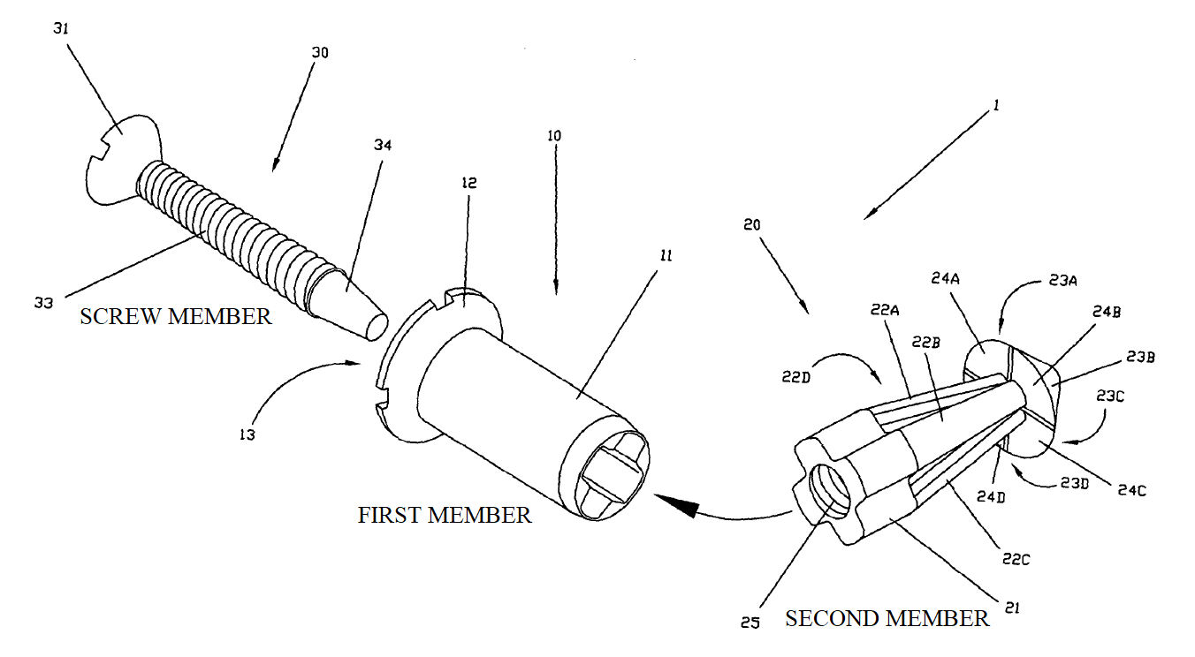
- The patented fastener comprises (in this embodiment, consists of) the three members shown. The first member is a substantially hollow sleeve. The aperture shown at the right of the first member is of a size and shape to accommodate the second member such that the second member may not rotate relative to the first member. The screw member may be passed through the first member to engage the threaded aperture of the second member.
- This embodiment in use is illustrated in Figures 3A and 3B:

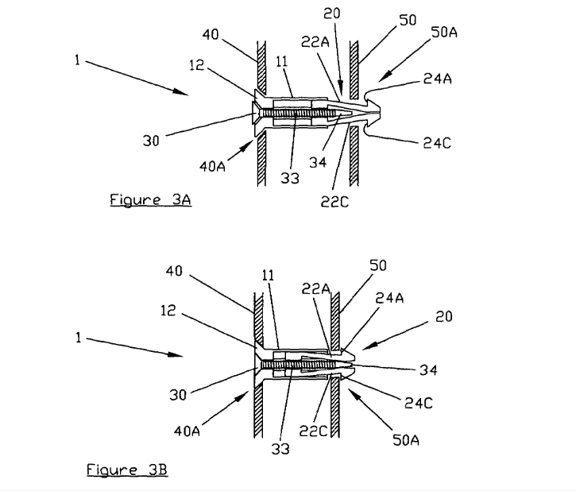
- The fastener as a whole is passed through an aperture in workpiece 40. I will call this the upper workpiece, as did the experts, since the technician will generally be above the two workpieces. Here it is shown to the left. It is also passed through an aperture in the lower workpiece 50, shown to the right. The head 12 of the first member engages the upper workpiece such that the first member can move no further down. Rotation of the screw member into the threaded aperture of the second member causes the second member to slide upwards, towards the first member. At the same time the tapered end of the screw member pushes against the flexible fingers of the second member (22A, 22C – as shown in Figure 1; typically there are four). The fingers are thereby biased radially outwards. As the second member moves further towards the first member, the planar surfaces of the splayed fingers engage with the face of the lower workpiece. Further rotation of the screw member draws the two workpieces together so that they are fastened.
- When the fastener is to be removed, the foregoing steps are carried out in reverse. The screw member is rotated in the opposite direction. The first and second members move apart and the flexible fingers move radially inwards. The fastener can then be withdrawn through the aperture in each workpiece.
- It was common ground that Figures 3A and 3B are missing a feature, in that nothing but a cavity is shown between the workpieces. An exact repeat of what is shown in those diagrams would result in each workpiece being displaced toward the other as the screw member is turned so that no clamping force could be applied by the fastener. However, the experts agreed that the reader of the Patent would understand that the workpieces must be braced apart by some means or be thick enough to be in contact with one another.

The claims
- Independent validity was asserted for four of the claims: 1, 8, 16 and 18. Claim 18 is the only method claim, taking the form of a method of using the claim 1 fastener. The parties divided claim 1 into convenient integers:

Claim 1
- A removable blind fastener comprising
- (a) a first member having an elongate body
- with a head at one end,
- (b) a second member having an elongate body
- extending from and adapted to slide relative to the first member,
- said second member having at least one flexible finger
- with a finger head at one end remote from the first member,
- (c) a screw member having a screw head adjacent the first member head
- and a screw shaft
- which passes through a restriction in the head end of the first member,
- wherein the restriction prevents removal of the second member from the head end of the first member,
- and wherein the screw member engages with a threaded aperture on the second member,
- rotation of the screw member in one direction sliding the second member towards the first member
- and biasing the or each flexible finger radially outward
- and rotation of the screw member in the other direction sliding the second member away from the first member
- and allowing the or each flexible finger to move radially inwards,
- and wherein, in use, the fastener comprising a unit of the first member, second member and screw member
- is insertable and removable through an aperture in each of two workpieces which need joining together
- with the head of the first member located against a face of one workpiece,
- and rotation of said screw causing the or each flexible finger to expand radially outward
- so the finger head on the or each finger engages a face of the other workpiece and causing the two workpieces to be drawn together as said second member slides towards the first member.
- Claim 8 requires the planar surface of the finger heads of the second member, as shown in the Figures:

“8. A removable blind fastener in accordance with any preceding claim, wherein each finger head provides a planar surface to engage with a planar surface of a workpiece face to prevent damage to a workpiece.”
- Claim 16 further requires the head of the first member to be adapted to receive a tool to prevent it from rotating:

“16. A removable blind fastener in accordance with any preceding claim, wherein the first member head is adapted to receive a tool to prevent it from rotating whilst said screw head is rotated.”
- It is sufficient to characterise claim 18 as being a claim to the method of using a fastener of claim 1.

The Skilled Person
- Although there was no apparent dispute about the identity of the skilled person, that identity was not pinned down by either side. The skilled person is an engineering technician, typically employed in the aerospace industry, with practical experience in the use of temporary fasteners for product manufacture and maintenance.

Common General Knowledge
- The experts agreed that the skilled person’s common general knowledge would have encompassed a variety of both permanent and temporary fasteners.
- In paragraph 6 of the Amended Grounds of Invalidity Airbus pleaded a list of matters which formed part of the common general knowledge. Save in relation to the E-Nut, the list was not challenged.
- With regard to the E-Nut, Mr McKay said in his report that he had never come across it by the filing date and he was not challenged on this. In cross-examination Mr Jack accepted that it was a reasonable opinion that the E-Nut was not well known by 2008. I find that the E-Nut did not form part of the common general knowledge.

Scope of the Claims
- Since Actavis UK Ltd v Eli Lilly and Co [2017] UKSC 48 there have been two steps to ascertaining the scope of a patent claim. The first is to decide what the claim means in accordance with the general rules of construction of a document, see Actavis at [58] and Trump International Golf Club Scotland Ltd v Scottish Ministers [2015] UKSC 74, at [33]. This has sometimes been referred to as the “normal construction” of a claim. It is a purposive construction, the inventor’s purpose being ascertained from the description and the drawings as they would be understood by a person skilled in the art with the common general knowledge in mind, see Icescape Ltd v Ice-World International BV [2018] EWCA Civ 2219, at [60].
- If a product or process does not infringe the claim as a matter of normal construction, the analysis moves to the second question which is whether the product or process nonetheless falls within the scope of the claim because it varies from the invention according to the normal construction in a way or ways which is or are immaterial.

Normal Construction of the Claims of the Patent

Claim 1

Integer (1) – removable fastener
- Temporary fasteners were part of the common general knowledge. An example of their use is given in the second paragraph of the Patent specification and was recognised by both experts. This is the fixing of a “skin panel” of an aircraft wing to the skeleton of the wing. The panel is held in the correct position relative to the skeleton by temporary fasteners. Permanent fasteners are then installed, after which the temporary fasteners are removed.
- Both experts distinguished “fly-away” fasteners, which remain in place even when the aircraft enters use and “non-fly-away” fasteners which are removed before flight, generally shortly after they are no longer needed.
- The claim does not characterise the fastener as being temporary, but “removable”. As a matter of ordinary English the two words do not mean the same thing.
- Neither expert said that “removable” was a term of art. No doubt any fastener can be removed with the application of sufficient force but neither expert understood “removable” as used in the Patent to be meaningless on the ground that all fasteners are removable in that sense. Nor do I.
- Mr McKay took the meaning of “removable” from the specification. He understood it to mean a temporary fastener of the type referred to in the second paragraph, which is entirely removed after it has completed its task of temporary fastening. A removable fastener is a non-fly-away fastener. That was Kwikbolt’s contention at trial.
- Mr Jack countered this by saying in his report that the skilled person would have known of the E-Nut fasteners and that these were both fly-away and removable, implying that the skilled person would contemplate the possibility that fasteners could be both. But as I have said, in cross-examination he conceded that it would be reasonable to suppose that the E-Nut was not well known by 2008. Also, Mr McKay was not challenged on his evidence that the E-Nut is not removable because its sleeve insert remains secured to the workpiece.
- Kwikbolt’s contention that a “removable” fastener is a non-fly-away fastener introduces an impermissible temporal element into claim 1. It is a product claim. To fall within the claim a fastener must satisfy the claim structurally, be suitable for use as a blind fastener and be suitable for removal. There is no requirement that the fastener must be removed before flight or at any other particular time. In principle, a fastener could be both fly-away and removable – if it were only ever removed during aircraft maintenance for instance.
- Mr Jack spoke of what he called “key characteristics” of a removable fastener, namely the provision of dowelling support and not being of a nature to create foreign object damage. Mr McKay said that a removable fastener will not necessarily provide dowelling support and was not challenged about this.
- A removable fastener may have this or that undesirable characteristic, but the presence of any of these does not perforce mean that it is not a removable fastener. Moreover, cross-examination of Mr Jack on this point oscillated between use of the terms “temporary” and “removable” without establishing whether a temporary fastener as understood at the priority date was the same thing as a removable fastener of the Patent.
- There must be a sliding scale of difficulty in removing a fastener, with a point beyond which a skilled person would cease to regard it as removable. Neither expert addressed the meaning of “removeable” in exactly that way, nor was it put to either of them in that way. If there was a commonly held criterion by which the skilled person would have understood whether a fastener is removable, it did not emerge from the experts.
- Airbus’s contention was that a fastener is removable if it can be removed without destroying the fastener. Mr Jack said in cross-examination that an essential requirement of a removable fastener was that it did not cause damage to the workpieces being clamped.
- This contention and evidence provided the best approach to the meaning of “removable” that was available. I conclude that a fastener is removable within the meaning of the Patent if it is suitable for removal in its entirety from the workpieces which it is clamping without thereby causing significant damage either to the fastener or to the workpieces.

Integer (2) – an elongate body
- Neither expert said that “elongate” is a term of art. As a matter of ordinary English, “elongate” when used as an adjective means that the noun in relation to which it is used – the thing described – is longer than it is wide. The length of the first member of the Patent is clearly the dimension parallel with the axis of the fastener. The width is the dimension perpendicular to the length, being the diameter of the first body if it is cylindrical. According to that simple meaning, integer (2) would require the length of the first member to be greater than its width. Kwikbolt endorsed this construction.
- Airbus’s expert, Mr Jack, said in his first report that the skilled person would understand from the Figures of the Patent that the first member must be substantially longer than it is wide. In cross-examination he said this meant that it must be three to four times longer than it is wide. The only justification for this was Mr Jack’s impression of the Figures.
- The Figures of the Patent show an embodiment of the invention. The invention is not what is shown in the Figures but what is claimed in the claims. Moreover, the Figures are diagrammatic, not scale drawings. The skilled person would not expect to glean relative dimensions, even of the embodiment shown, with any accuracy from the Figures.
- In a letter dated 3 February 2021, 6 days before the trial, Airbus’s solicitors wrote to Kwikbolt’s solicitors proposing a new construction of “elongate”:

“… our contention [is] that ‘elongate’ within the meaning of the Patent’s claim 1 means that the shape of the body of the first member is such as to allow that body to be inserted into the holes in the workpieces. That is not the case with the Centrix Free Spin Fasteners (whether or not they are variants including the optional end cap).”
- This idea was too new for Mr Jack to have said anything about it, but it was repeated in Airbus’s skeleton. In fact, the skeleton developed the argument by saying that the first member sits within both of the holes in the workpieces to provide dowelling support.
- There is nothing in the specification about a need for dowelling support and elongate is used to characterise the body of both the first and second member.
- I see no reason for supposing that “elongate” is to be given any specific or narrow meaning. It should be given its ordinary English meaning. Its use in claim 1 means only that the first and second members must each be longer than it is wide.

Integer (3) – a head at one end
- The first member must have a head. Mr Jack said in his report that as a matter of normal engineering language a “head” of a component such as a bolt or screw is an element that has a larger diameter than the body of the component, such that it extends from the body in order to provide a bearing surface. The latter means an area of contact between two elements at which purchase or pressure may be applied. In the context of the Patent the head of the first member bears upon the left hand workpiece (as shown in the Figures) and must therefore be at the end of the first member proximal to the technician.
- Mr McKay agreed with Mr Jack to the extent that the head of the first member must be suitable for locating against a face of one workpiece, as required by integer 1(19). It could be more than one workpiece and no particular workpiece is specified. Mr McKay also said that the diameter of the head must be greater than that of the aperture of the workpiece against which it is located. Beyond that, so far as Mr McKay was concerned, the claim imposes none of the more detailed requirements suggested by Mr Jack.
- I agree with Mr McKay. I can see no support in the claim or in the specification for the detailed meaning of integer 1(3) adopted by Mr Jack. I did not understand Mr Jack to be saying that “head” is a strict term of art such that the head of any component must invariably have a larger diameter than that of the component’s body. If he was saying that, he pointed to no documentary support for head as a term of art and Mr McKay did not endorse that idea.
- A head will provide a bearing surface; in the case of a component such as a bolt or a screw, because of the way they are generally used one would expect the head to be larger than the body of the bolt or screw so that the head can provide a bearing surface. The purpose of the head of the first member of the Patent, as both experts agreed, was to bear upon a workpiece. It must therefore be larger in diameter than the aperture of the workpiece against which it bears. In the context of the claim, the relative diameter of the head and the rest of the first member is of no purposive significance. In my view, therefore, the skilled person would not interpret the term “head” to require that its diameter be greater than that of any other particular part of the first member.
- The head must be at one end of the first member. The claim does not expressly specify which end. For the reasons given above, the head is defined by its purpose: to bear against the face of a workpiece. Whichever part of the first member does that is the head.

Integer (8) – a screw head adjacent the first member head
- The argument was about the meaning of “adjacent”, which is not a term of art. As a matter of ordinary English, it means adjoining or bordering but not necessarily touching. Kwikbolt’s written case in closing was this:

“The skilled person would therefore appreciate the adjacency of the screw head to the first member head as opposed to the screw head being proximate to the finger ends of the second member. This is wholly consistent with the purpose of the screw head being near to the first member head, so as to allow the fastener to act as a blind fastener – i.e. one that can be inserted and operated from one side.”
- I do not find this clear, but it appears to be a submission that all this integer requires is that the screw head is at the end of the fastener away from the flexible fingers so that it is accessible. Mr Vanhegan submitted that Mr Jack had agreed with this interpretation of “adjacent” in cross-examination. He did not. He went no further than agreeing that the screw head must be on the upper side of the workpieces and at some distance from the heads of the flexible fingers. That is self-evidently correct but does not assist in the meaning of “adjacent” in this integer. This is the relevant passage of cross-examination:

“Q. Yes. The screw head, because it is on the top part of the panels, it must be located away from the finger member heads of the collet?

A. Yes, sir.

Q. Because they have to be on the other side of the panels; correct?

A. Yes, sir, that is correct.

Q. So the screw member head has to be distant from the finger member heads; correct?

A. Some distance, yes, sir.

Q. But it must be adjacent to the first member head?

A. Adjacent means touching? Or on the same side?

Q. On the same side; correct?

A. Yes, sir.”
- It was Mr Jack who asked Mr Vanhegan what he meant by “adjacent”. Counsel said he meant on the same side of the panels as the first member heads. At most, Mr Jack was agreeing that the screw member head must be on the same side of the workpieces as the first member head. That is clearly correct, otherwise the fastener would not be blind. This says nothing about the meaning of “adjacent”.
- It must also be borne in mind that this integer of claim 1 positions the screw head by reference to the head of the first member, not by reference to one end of the fastener as a whole.
- Airbus argued that it was self-evident that the screw head must be at the same end of the fastener as the first member head. Therefore, Mr Ward submitted, “adjacent” must mean more than that: it requires that the two heads be in contact. I think it is a mistake to assume that every integer of a patent claim must invariably go beyond stating the obvious. Even assuming this one does, it does not follow that the screw head is in contact with the first member head.
- Mr McKay was cross-examined on this topic by reference to a diagram of the Centrix fastener in Airbus’s product and process description. He agreed that the location of the screw head of the Centrix Fastener – at which end of the first member it will be located – is fundamental to the way in which these particular fasteners work. That may be right, but claim 1 cannot be construed by reference to the Centrix Fastener.
- In my view, “adjacent” must be interpreted according to normal usage of the word. The screw head must adjoin the head end of the first member but they need not touch. Thus, the screw head must adjoin the end of the first member which bears against the workpiece.

Integers (17)-(19) – fastener comprising a unit is insertable and removable through an aperture in each of two workpieces
- The debate concerned what was meant by “in use, the fastener comprising a unit of the first member, second member and screw member” being insertable and removable through an aperture in each of the two workpieces. No direct guide is given in the specification as to what this means.
- Mr Jack said that each member must in use penetrate the aperture in each of the two workpieces. However, as Mr McKay said, in no embodiment of the Patent is the first member inserted into both workpieces.
- Some meaning must be given to the requirement that the fastener, in use, is insertable and removable as a unit. I agree with Mr Jack that this can be understood by the way in which the fastener is shown to operate in the Patent. The three members acting as a unit are shown to be inserted and removed through an aperture in each of the two workpieces:

“As shown in Figures 3A and 3B, fastener 1 can be inserted through an aperture 40A in workpiece 40 and through an aperture 50A in workpiece 50, to join the two workpieces together.

…

“Rotation of the screw member 30 in the other direction slides the second member 20 away from the first member and allows the flexible fingers 22A, 22B, 22C, 2D to move radially inwards again back into the position shown in Figure 3A. Fastener 1 can then be withdrawn from the aperture 40A, 50A in workpieces 40, 50.”
- There are three aspects to this. First, it does not matter whether one or other of the three members viewed individually is insertable or removable through an aperture in both workpieces. It was common ground that the head of the first member must sit against the surface of the left hand workpiece. Therefore not all of the unit will pass through the aperture in the upper workpiece and indeed not all of the unit will pass through the aperture of the lower workpiece either.
- Secondly, although the three members move relative to one another in use, during insertion or removal from the apertures in the workpieces they go in or come out, as the case may be, as a single unit – in other words they do not go in or come out separately.
- Thirdly, the fastener as an entire unit, the whole thing, must be insertable and removable, in particular removable according to the meaning of that term which I have adopted above.

Claim 16 – the first member head is adapted to receive a tool
- I did not detect any difference between the experts after cross-examination as to the construction of this claim and I think it presents no real difficulty. When the screw member is rotated, this generates a torque in the second member, transferred to the first member. The first member must be prevented from rotating with the screw, otherwise the rotation of the screw would not cause the second member to slide towards the first member and the fingers of the second member would not be biased radially outwards. Claim 16 requires that the first member head is adapted to receive a tool to prevent it rotating.
- Airbus argued that the word “receive” implies a requirement that the first member head must be suitable for having the tool inserted into it. I think that Airbus’s expert, Mr Jack, summarised the position correctly in his first report:

“The Skilled Person would understand this integer to mean that a tool is to be applied to the head of the first member to hold it in place. As described at paragraph 6.11 above, the Patent provides the example of having slots in the head 12 of the first member 10 – insertion of a tool (like a screwdriver) into these slots would provide anti-rotation means.”
- The purpose of this integer is to provide a means of holding the head of the first member in place. The first member head must therefore be adapted to receive a tool in the sense of being adapted to engage a tool such that the rotation of the first member can be restrained. As Mr Jack says, the Patent provides an example of slots in the head to receive a screwdriver, but it is no more than an example.

The product alleged to infringe
- Airbus admits that the Centrix Fastener has a first, second and screw member as claimed in the Patent and as shown in this diagram, which also labels Airbus’s identification of the restriction of integers 1(10) and (11) in the Centrix Fastener.

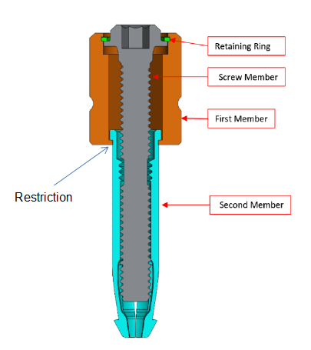
- By the time of the trial, the integers of the claim which Airbus alleged were not embodied in the Centrix Fastener were integers 1(2), 1(3), 1(8), 1(17) and 1(18) of claim 1 and claim 16. There were integers of claim 18 corresponding to those of claim 1 which were in dispute but they raised no separate issues.
- Since there was no consensus about the construction of “removable”, I must also consider integer 1(1).

Integer 1(1) - removable
- The PPD describes the removal of the Centrix Fastener by rotating the screw member in the direction opposite to that of fastening, causing the second member to move downwards within the first member, releasing the pressure of the fingers on the workpiece and then causing them to move radially inwards. The PPD then says:

“The device can then be removed through the hole in the tope work surface ahead of disassembly and re-use.”
- There is nothing there to suggest that removal of the Centrix fastener in its entirety would give rise to any significant damage to either the fastener or to the workpieces. In fact, the ease of removal is within the control of the user, not Centrix. The user can adjust the diameter of the apertures in the workpiece. The Centrix Fastener must inevitably be suitable for removal from workpieces without significant damage to it or the workpieces. Integer 1(1) is satisfied.

Integer 1(2) – a first member with an elongate body
- Airbus’s argument of non-infringement depended on a construction of “elongate” which I have rejected. The first member of the Centrix Fastener is longer than it is wide.

Integers 1(3) – a first member with a head at one end
- I have found that the first member head is that part of the first member which bears against the face of a workpiece. The head must be larger in diameter than the aperture of the workpiece. The following diagrams illustrate the Centrix Fastener:

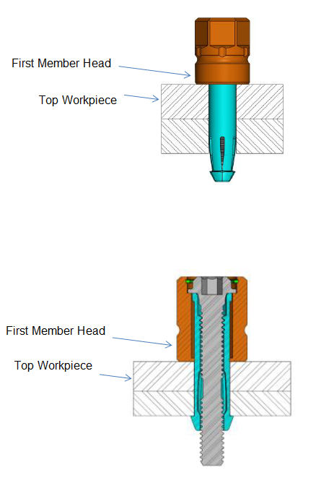
- The first member has a head at one end as shown in the diagrams, so this integer is satisfied.

Integer 1(8) – a screw head adjacent the first member head
- I have found that on a correct construction of this integer the screw head must adjoin the head end of the first member. It does not – it adjoins the opposite end of the first member. This integer is not satisfied.

Integers 1(17) and (18) – in use, a unit of the first, second and screw members is insertable and removable through an aperture of each of the two workpieces
- The Centrix Fastener embodies these integers on the construction of those integers found above.

Integer 16
- On the construction of integer 1(3) and integer 16 found above, this integer is not embodied in the Centrix Fastener. It is not the first member head which is adapted to receive the tool.

Conclusion
- Because integer 1(8) and its equivalent in claim 18 are not satisfied, the Centrix Fastener falls within none of the claims of the Patent on a normal construction.

An equivalent

The law
- I here set out paragraph [66] of Lord Neuberger’s judgment in Actavis UK Ltd v Eli Lilly and Company [2017] UKSC 48. Having considered, among other cases, Improver Corp v Remington Consumer Products Ltd [1990] FSR 181 (from which had been drawn the “Improver questions”) and Eli Lilly & Co v Ratiopharm GmbH (Case No. 6 U 3039/16), 18 May 2016, Oberlandesgericht Munich, Lord Neuberger said:

“[66] In these circumstances, given the weight that has been given by courts in this jurisdiction (and indeed in some other jurisdictions) to the three ‘Improver questions’, I think it must be right for this court to express in our own words our reformulated version of those questions. In doing so, it is right to emphasise, as Lord Hoffmann did in Kirin-Amgen [2005] R.P.C. 9, at [52], that these questions are guidelines, not strict rules (as indeed the Oberlandesgericht indicated in Case No. 6 U 3039/16, when saying that it was ‘generally’ true that ‘three requirements must be met’). While the language of some or all of the questions may sometimes have to be adapted to apply more aptly to the specific facts of a particular case, the three reformulated questions are as follows:

(i) Notwithstanding that it is not within the literal meaning of the relevant claim(s) of the patent, does the variant achieve substantially the same result in substantially the same way as the invention, i.e. the inventive concept revealed by the patent?

(ii) Would it be obvious to the person skilled in the art, reading the patent at the priority date, but knowing that the variant achieves substantially the same result as the invention, that it does so in substantially the same way as the invention?

(iii) Would such a reader of the patent have concluded that the patentee nonetheless intended that strict compliance with the literal meaning of the relevant claim(s) of the patent was an essential requirement of the invention?

In order to establish infringement in a case where there is no literal infringement, a patentee would have to establish that the answer to the first two questions was ‘yes’ and that the answer to the third question was ‘no’.”
- As Lord Neuberger made clear in his subparagraph (i), the “invention” he refers to in the three reformulated questions is the inventive concept.

The Inventive Concept
- There was a brief debate about the precise meaning in law of the inventive concept of a claim and whether it differed in the alternative contexts of the doctrine of equivalents, obviousness and disputes as to entitlement to a patent, a matter I discussed in BDI Holding GmbH v Argent Energy Ltd [2019] EWHC 765 (IPEC). Counsel disagreed about this but it is of limited relevance here. Both counsel went forward on the basis that the inventive concept is the new technical insight revealed by the invention as claimed, in the context of the specification as a whole, as it would have been perceived by the skilled person at the priority date. The common general knowledge of the skilled person will be an important influence on this perception.
- The Patent itself is of no assistance in determining the inventive concept. As I have noted, it begins with an inaccurate statement of the problem which the invention is said to solve, namely the need for a temporary fastener and temporary fasteners were by common consent part of the common general knowledge at the filing date.
- Kwikbolt’s pleaded the inventive concept of claim 1 this way:

“The removable blind fastener is inserted as a unit into apertures in two or more workpieces, with the first member head abutting a face of the proximal workpiece. Rotating the screw member in one direction slides the second member towards the first member, biasing the fingers outwardly such that the finger heads engage a face of the distal workpiece, and draw the workpieces together. Rotating the screw member in the other direction reverses this operation, disengaging the fastener from the workpieces and allowing the fastener to be removed as a unit from the workpieces.”
- Although the pleading was qualified in that it was made pending expert evidence and/or such further points as may emerge, in closing Mr Vanhegan confirmed that Kwikbolt’s statement of the inventive concept of claim 1 remained unchanged.
- Airbus’s version of the inventive concept was this:

“A three piece removable blind fastener the configuration of which ensures that the bulk of the fastener is below the top surface of the work-piece. More specifically this is achieved by having a first member comprising an elongate body with a head at one end, which is insertable through an aperture in each of the two workpieces which need joining together such that the head of the first member is located against a face of one workpiece.”
- The doctrine of equivalents as explained in Actavis requires the variant to be specified. This will be the invention of one of the claims of the patent in suit with one or more integers missing or modified. In the simplest case one integer of the claim is missing in the variant – this will be the integer in issue. The parties will know what that integer is and each may tend to tailor its inventive concept accordingly. If so, the integer in issue is liable to be irrelevant to the inventive concept advanced by the patentee but central to the inventive concept advanced by the alleged infringer.
- The variant in issue here is a removable blind fastener with all the features of claim 1 save integer 1(8): the head of the screw member is not adjacent to the head of the first member.
- Kwikbolt has drafted its inventive concept so as to conspicuously omit integer 1(8). When the reformulated Improver questions in Actavis are put by reference to Kwikbolt’s inventive concept and the variant in issue here, the answers favour Kwikbolt.
- Airbus sought to hedge its bets. The inventive concept was apparently intended to highlight three features of claim 1, making any or any combination of them central. They are: (a) having the bulk of the fastener below the top surface of the workpiece, (b) the first member having an elongate body and (c) having the first member insertable through an aperture in each of the two workpieces while the head of the first member is located against one workpiece. The second of these is irrelevant on my findings above. The third is difficult to understand. As shown in Figures 3A and 3B of the Patent the first member is not insertable through an aperture of both workpieces, only the upper workpiece. I do not see that it must be insertable through both. I will come back to the first.
- The important point, in my view, is that a correct assessment of the inventive concept cannot be achieved with the variant in mind. The correct identification of the inventive concept must be done through the eyes of the skilled person, who has no notion of what the variant is. The skilled person has only the relevant claim, the specification as a whole and his or her common general knowledge to work with. Only after the inventive concept has been identified does the variant and with it the integer(s) in issue come into play so that the three Actavis questions (the reformulated Improver questions) may be considered.
- As to Kwikbolt’s inventive concept, Mr Jack pointed out that it reads on to a fastener which formed part of the common general knowledge, known as the “threaded Cleco”, the structure of which Mr Jack explained in his first report. He was not challenged on this evidence. Consequently the skilled person would not have adopted Kwibolt’s assessment of the inventive concept of claim 1 of the Patent.
- With regard to Airbus’s inventive concept, I was shown Kwikbolt’s PCT Application, publication no. WO 2009/095640 A1. It takes priority from the UK application for the Patent. Its specification is more developed than that of the Patent. The description of the prior art refers to a Figure 1 (not in the Patent) which illustrates what is described as a conventional fastener. It states:

“As can be seen from Figure 1, the bulk of the fastener is above the top surface of the work-piece and is therefore exposed and vulnerable and presents an obstruction on the surface of the work-piece. This is a particular problem in automated assembly processes; tool heads sweep rapidly across the surface of the materials and protruding fasteners will impede the movement of these automated tools. Another problem with the prior art shown in Figure 1 is that the maximum clamping pressure is determined by the strength of the internal spring.”
- Of course, the skilled person is not taken to have read this PCT Application when hypothetically considering the inventive concept of the Patent. However, the PCT Application is Kwikbolt’s own representation and provides a potential guide as to what the skilled person would have understood the inventive concept of the Patent to be, viewed through the lens of his or her common general knowledge. The first two sentences of the passage I have quoted are consistent with what Mr McKay had to say. He confirmed in cross-examination that at the priority date the skilled person would have been interested in making a fastener compatible with automated machinery used in aircraft assembly. Generally, if the fastener was proud of the workpiece surface this complicated the programming of automated machinery, requiring the machinery to dodge the fasteners. Further, there was no evidence of a prior art fastener within the skilled person’s common general knowledge which was blind, removable and which did not protrude above the surface of the workpiece when in clamping mode.
- In respect of the final sentence of the passage I have quoted from the PCT Application, I am not able to reach any conclusion on the evidence as to how the skilled person would have regarded the clamping pressure of a fastener according to claim 1 of the Patent when compared with blind removable fasteners within his or her common general knowledge.
- The advantage of a removable blind fastener which does not protrude above the upper workpiece is broadly consistent with the first feature which Airbus chose to highlight in its inventive concept, but I do not see why that feature should be characterised as having the bulk of the fastener below the top surface of the workpiece. I think a more accurate characterisation is that in clamping mode the fastener is substantially flush with the upper surface of the upper workpiece.
- I take the inventive concept of claim 1 of the Patent to be the technical insight that a blind removable fastener having the features of claim 1 will be an improvement over blind removable fasteners of the prior art in that in clamping mode its upper surface will be substantially flush with the upper surface of the upper workpiece.
- The significance of this is that having the screw head adjacent the first member head, in other words having integer 1(8), is an important part of implementing the inventive concept. If the screw head is not adjacent to the head of the first member, the head of the first member must then be at the distal end of the first member (from the perspective of the technician), where it bears on the upper workpiece. In that event the first member will stand proud of the workpiece in clamping mode.
- Taking the inventive concept of claim 1 and the variant as I have identified them, the answer to the first Actavis (reformulated Improver) question is that the variant does not achieve the result of the inventive concept at all. The Centrix Fastener does not exploit the inventive concept of claim 1. The scope of claim 1 is not extended by the doctrine of equivalents to cover the Centrix Fastener.

Conclusion on infringement
- The Centrix Fastener does not infringe claim 1 of the Patent, whether on the normal construction of the claim or pursuant to the doctrine of equivalents. It follows that the Centrix Fastener does not infringe any of the claims.

Validity

The pleaded prior art
- Airbus relied on two items of prior art in support of its argument for lack of novelty:
- US Patent no. 2005/0169726 A1 (“McClure 1”).
- The E-Nut.
- As pleaded, the E-Nut was cited by way of a back-up. It is said to be a specific embodiment of McClure 1 and the Grounds of Invalidity assert that McClure 1 provides a full description of the E-Nut; in case Kwikbolt contends that it does not, Airbus relies on the prior public use of the E-Nut.
- In support of its argument of lack of inventive step, Airbus pleaded reliance on McClure 1, the E-Nut and
- PCT Application no. WO 2004/037483 A1 (“McClure 2”) and
- UK Patent no. 413,403 (“Wylie”).

Application at the start of the trial regarding the E-Nut
- As I have mentioned, there was an application by Kwikbolt at the start of the trial to disallow Mr McClure’s evidence in its entirety because it should only have addressed whether the E-Nut had been made available to the public before the Patent’s filing date and Kwikbolt conceded that point. From this there emerged a larger dispute at the start of the trial which I must now deal with: what should be understood by “the E-Nut” as pleaded?
- Apparently the E-Nut has been marketed in various versions and Airbus said that it was entitled to rely on several alternatives as pleaded prior art. Mr Ward took me to the evidence of Mr McKay to show that Mr McKay had appreciated that the E-Nut came in different versions and that Kwikbolt must have been equally aware of this and that the various versions all formed part of Airbus’s case. He submitted that Kwikbolt’s attempt to limit the attack on lack of validity and inventive step with regard to the E-Nut to one version should have been made much earlier. He further submitted that Kwikbolt’s application should be refused for four reasons.
- First, Kwikbolt must have understood that it would be absurd for Airbus to rely only on the version that did not matter. Secondly, McClure 1 shows that the E-Nut as there disclosed may be implemented in different ways. Thirdly, the Grounds of Invalidity refer to Annex 4 to that pleading which shows the E-Nut comes in different versions. Fourthly, Annex 2 to the same pleading shows the same thing.
- Mr Ward finally submitted that if I were minded to limit Airbus’s case as Kwikbolt sought, I should give Airbus permission to amend its Grounds of Invalidity so that the trial could continue with Airbus relying on all versions of the E-Nut.
- I ruled that Airbus could rely only on the version of the E-Nut referred to in paragraph 3(d) of the Amended Grounds of Invalidity and that I would give my reasons in the judgment after trial. Those reasons now follow.
- It is not unusual for industrial products to be marketed in alternative models or versions, often many. I take the view that when a party pleads such a product in support of an allegation of lack of novelty and/or inventive step, it is essential that the pleading is entirely unambiguous as to which version of the product is relied on. First, the patentee is entitled to know the case it has to meet. Secondly, this court (and indeed the Patents Court) routinely limits a party seeking to challenge the validity of a patent to reliance on a small number of items of prior art. It requires the party to focus its attention on its best case and thereby avoids a waste of time and expense, not least the time of the court. This is plainly in conformity with the overriding objective. It would undermine that routine approach if a party were entitled to plead reliance on product X without further detail and thereby to smuggle into the case any number of alternative versions of product X.
- These are the relevant paragraphs of Airbus’s Amended Grounds of Invalidity:

“3. A specific embodiment of McClure 1 was a commercial product known as the ‘E-Nut’. The Defendant contends that a full description of that commercial product is provided in McClure 1. If and insofar as the Claimant seeks to contend that elements of the operation of the E-Nut are not disclosed in or directly ascertainable from McClure 1 however, the Defendant will rely on the prior public use of the E-Nut, which was widely publicly available from at least 2003. Indeed, such was the widespread use of the E-Nut that the Defendant contends that it formed part of the common general knowledge of the skilled person as further set out below. The Defendant relies on the following particulars in support of the prior public use of the E-Nut:

a. The E-Nut was manufactured by Avibank and was commercially available in at least the United States from at least 2003. The E-Nut is still manufactured and sold commercially by Avibank (see Annex 2 – extract of the E-Nut page from Avibank’s website);

b. The trade mark filing for ‘E-Nut’ at the USPTO (Registration number: 3361456), filed by Avibank Mfg., Inc. notes that the first use in commerce of the goods to which the trade mark relates was 11 October 2002. A copy of the relevant page of the entry for the mark at the USPTO is attached as Annex 3.

c. To further support that the E-Nut was available prior to the priority date of the Patent, the Defendant relies on the display of the E-Nut at a trade fair in Hamburg in spring 2004 at which E-Nut fasteners were displayed as part of an installation displaying the new Boeing 787 flooring system. Photographs from this exhibition are attached as Annex 4.

d. An E-Nut is in the possession of the Defendant and available for inspection on request. The E-Nut in the Defendant’s possession is of the same design as those available before the priority date of the Patent.

4. Further and in any event none of claims 1 to 18 of the Patent is in respect of a patentable invention in that the same was obvious to a person skilled in the art having regard to the state of the art which comprised the following matter at the priority date of the Patent:

a) The matters referred to above;

b) WO2004/037483A1 (‘McClure 2’); and

c) GB 413,403;

in conjunction with the common general knowledge. The Defendant refers to the amended claim chart at Annex 1.”
- I think that any reasonable reader of those paragraphs would take the E-Nut to be a single product in a single version. Paragraph 3(a) would be understood to mean that this product was available from 2003 and that Annex 2 provides confirmation of this. Paragraph 3(c) would be taken to mean that it was displayed at the Hamburg trade fair and that Annex 4 provides confirmation of that prior disclosure. If any doubt were generated by the fact that Annexes 2 and 4 show alternative versions of the E-Nut, paragraph 3(d) would be taken to provide a clear answer: the version relied on is that made available to Kwikbolt for inspection. One version only was made available. In my view that is the single version pleaded and the only version on which Airbus is entitled to rely.
- Moreover, Mr Vanhegan said that in reliance on the pleading Kwikbolt had not investigated whether there had been prior use of versions of the E-Nut other than that pleaded and had not served evidence addressing the point. Mr Ward accepted that Kwikbolt’s evidence did not cover the question of prior use of other versions.
- I agree with Mr Ward that Kwikbolt should not have sprung its application to limit the scope of Airbus’s reliance on the E-Nut at the last minute. However, in this instance Airbus either knew or certainly should have known since the service of the Amended Grounds of Invalidity that Kwikbolt was entitled to understand that only one version of the E-Nut had been pleaded. I also think that Kwikbolt might be forgiven for having assumed that it made little difference so far as Airbus was concerned: on Airbus’s case McClure 1 disclosed everything about the E-Nut on which Airbus wished to rely.

McClure 1
- McClure 1 claims an improved blind fastening system. It comprises three components: a sleeve insert, a collet body and a threaded stud. An embodiment is shown in Figures 15 and 16:

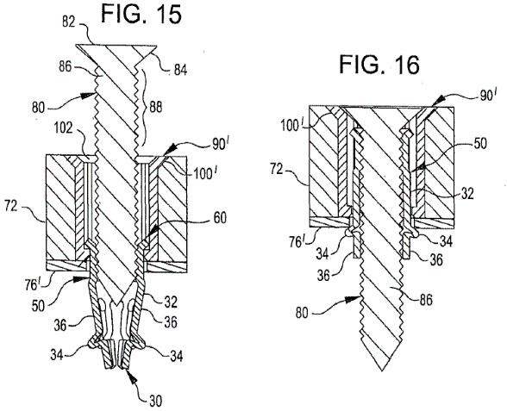
- Mr Ward provided a helpful simplification of Figure 16. The sleeve insert (the putative first member) is shown in red, the collet body (the putative second member) is shown in green and the threaded stud (the putative screw member) is shown in yellow:
- The collet body has flexible fingers at one end (marked 36 in Figures 15 and 16, with protruding portions 34). Mr Jack explained how the McClure 1 fastener works. The collet body is inserted through the top of the sleeve insert. The collet body is pushed down through the sleeve insert until its flange meets a rim or ledge in the sleeve insert. The rim or ledge is designed to prevent the collet body from falling out of the base of the sleeve insert. The flexible fingers in their resting state are sufficiently converged so that they can extend through the sleeve insert’s base. When the fastener is inserted into the apertures of the workpieces, the converged fingers can project through the aperture of the lower workpiece.
- The threaded stud is inserted through the top of the sleeve insert and into the collet body, engaging threads on the inner surface of the collet body. Rotation of the stud causes the collet body to be drawn up along the stud towards and into the sleeve insert. The bottom of the stud is forced through the collet body’s flexible fingers, causing them to expand outwards. The collet body is prevented from rotating in the sleeve insert by complementary internal geometry. As the collet body is drawn up, its flexible fingers, now pushed radially outwards, engage the surface of the lower workpiece. The sleeve insert has a flared upper lip which bears upon the upper workpiece. This and the flexible fingers bearing on the lower workpiece cause the two workpieces to be clamped.
- McClure 1 does not explain how the fastener would be removed. Mr Jack said that it would be clear to the skilled person that this would involve the reversal of the steps set out above.
- Mr McKay said in his first report that McClure 1 discloses versions of a blind fastener, none of which is removable. As accepted by both sides, for the fastener to work the sleeve insert must be kept from rotating when the threaded stud is rotated. Mr McKay’s point was that McClure 1 achieves this by attaching the sleeve insert to the workpiece. The sleeve does not leave the workpiece on removal of the fastener and therefore the fastener is not removable within the meaning of claim 1 of the Patent.
- Airbus advanced three arguments in relation to McClure 1 and claim 1 of the Patent. First, Mr Ward submitted that the fastening element of McClure 1 is removable even if the insert is not and therefore the fastener can be categorised as removable. This does not assist Airbus because I have found that “removable’ in the context of claim 1 requires the fastener as an entire unit to be removable.
- Secondly, Airbus relied on a particular embodiment of McClure 1, one which uses a sleeve insert as illustrated in Figures 15 and 16 and which is shown by itself in Figure 4:

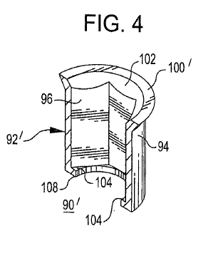
- There is discussion in paragraph [0061] of the embodiment using the sleeve insert of Figure 4. It expressly contemplates the user “adhering” the sleeve insert into the aperture of a workpiece. The discussion continues in paragraph [0063]. To put the relevant part of that paragraph into context, I will also quote the preceding sentence which refers to Figures 13 and 14:

“In FIGS. 13 and 14, sleeve insert 90 is secured to proximal panel 72 such as by adhering base 106 to the bottom surface of proximal panel 72 and the panel apertures are aligned. In FIGS. 15 and 16, sleeve insert 90′ is secured in the aperture of panel 72 such as by adhering outer surface 94 to the aperture of [proximal] panel 76′. Alternatively, but not shown, outer surface 94 can include a plurality of radially extending elements, such as knurling or vanes, that physically engage with a [proximal] panel.”
- Airbus relied on the words I have put into italics. Where I have put the word proximal in square brackets, it is because the paragraph says “distal” but the experts were agreed that the skilled person would have understood McClure 1 to have meant “proximal”.
- Mr Jack discussed that short italicised sentence. He said in his report that use of knurling or vanes would have been well-known to the skilled person as a means of creating friction with the surface of the panel, thus resisting rotation of the sleeve insert. The fit could be loose, close tolerance or interference fit. The choice would depend on how easily one wanted the insertion and removal of the sleeve insert to be. With a loose or close tolerance fit the sleeve insert could be pulled out of the aperture along with the stud and collet body. With an interference fit, a tool might be required.
- Mr McKay responded in his second report by saying that all of paragraph [0063] of McClure 1 is about securing the sleeve insert to the proximal panel, i.e. workpiece. He also said that knurling or vanes on the surface of the sleeve insert would risk causing damage to the workpiece and should be avoided at all costs in an aircraft assembly.
- Mr Jack was cross-examined on this:

“Q. All of the inserts in the McClure 1 patent work because they are fixed in the panels which are going to be clamped; is that not correct?

A. Yes, that would have to be correct.

Q. Yes. They are all describing what I think is called by Mr. McClure as an anchoring system, are they not?

A. Anchoring system, yes, sir.”
- Mr Jack went on to say that he thought that the clamping or anchoring disclosed in McClure 1 was very similar to the disclosure of the Patent. I am not sure what Mr Jack meant by similar.
- In cross-examination Mr McKay did not alter his evidence that the italicised sentence in paragraph [0063] was concerned with securing the sleeve to the workpiece. He was also cross-examined on the basis, as was put to him, that the skilled person would wish to avoid knurling because of potential damage and would think of using a tool and slots instead to prevent rotation of the sleeve insert. Mr McKay said:

“Well, yes, he needs to prevent rotation, obviously, for the component to work, as designed. You know, if he was an inventor, you know, yes, he might try to come up with some other version, but I guess that is always an option.”
- In summary, both experts believed that the skilled person reading McClure 1 would know that rotation between the sleeve insert and the collet body had to be avoided for the fastener to work. The solution disclosed in McClure 1 is to fix the sleeve insert to at least one of the workpieces. There is no suggestion anywhere in McClure 1 that the sleeve insert should be removable. The only option disclosed in McClure 1 that does not expressly require the sleeve insert to be adhered or otherwise fixed to a workpiece is that of using knurling or vanes as discussed in one sentence of paragraph [0063]. In theory it was possible to use a loose enough fit between the sleeve insert and the aperture to make removal of the sleeve insert easy. But as Mr McKay said, the teaching of paragraph [0063] is still all about ensuring that the sleeve is secured to the panel by one means or another. Further, the skilled person would find the option of using vanes or knurling unattractive since it would create a risk of damage to the workpiece. It would also not be removable in the sense that I have construed that word in the context of the Patent. In my view paragraph [0063] does not disclose a removable fastener.
- Mr Ward’s third argument was that claim 1 is a product claim and therefore sets out physical characteristics. All those characteristics are in the relevant embodiment taken from paragraph [0063] of McClure 1. I disagree. That embodiment is not a removable fastener as I have construed that term, requiring the entire unit to be suitable for removal without damage to the fastener or the workpieces.
- In my view there are no clear and unmistakable directions in McClure 1 to the invention of claim 1 because there is no disclosure of a fastener which is suitable for removal as a unit. On the contrary, the skilled person would understand that the sleeve insert should be secured to a workpiece. Claim 1 does not lack novelty over McClure 1.
- Turning to inventive step, I have identified the person skilled in the art and the common general knowledge above. The principal difference between McClure 1 and claim 1 of the Patent is that just identified: there is no teaching in McClure 1 that the sleeve insert should be removed and thus that the fastener as a unit is removable. It goes further. A key teaching of McClure 1 is to anchor the sleeve to the workpiece so that it cannot rotate in use. In my view the skilled person would not have thought it obvious at the filing date to abandon that central feature of McClure 1 which is necessary for the fastener to work. Claim 1 does not lack inventive step over McClure 1.
- There was a further argument, of secondary importance. It was that McClure 1 nowhere discloses a restriction in the head end of the first member, as required by integer 1(10) of the claim. Integer 1(11) identifies the function of the restriction: to prevent the removal of the second member from the head end of the first member. Mr Ward pointed to the top of the sleeve insert where there is a flange, marked 100′ in Figures 15 and 16. He said that was the head of the sleeve insert/first member. I think that is right, but there is no restriction shown there which prevents removal of the collet body/second member from that head.
- Little was said about whether it was obvious to add a restriction to the head of the sleeve insert/first member of the Figure 15/16 embodiment of McClure 1. Without assistance on this, it seems to me that it was probably obvious.
- However, claim 1 lacks neither novelty nor inventive step over McClure 1. The same therefore applies to claims 8, 16 and 18.

The E-Nut
- The E-Nut is a physical embodiment of one of the versions of the fastener disclosed in McClure 1. The sleeve insert/first member of the E-Nut must be glued to the underside of the upper panel or workpiece. The collet body/second member is pushed into the sleeve insert, after which the screw is rotated into the collet. The sleeve insert is not removable. Further, Mr Jack accepted in cross-examination that the E-Nut is not a blind fastener because access is required to the far side of the workpiece in order to install it.
- The E-Nut adds nothing to McClure 1.

McClure 2
- The invention of McClure 2 is entitled “Radial-Type Temporary Fastener, Components and Tool”. An embodiment is shown in Figure 10 which can be used to describe the invention as a whole:

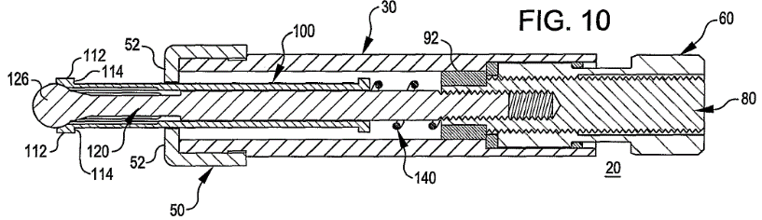
- There is a main body 30 (the putative first member), a collet 100 (the putative second member) and a spindle 120 (the putative screw member). The collet has flexible fingers at the end distal from the technician (to the left, as shown). The drive nut 60 is rotated and a tool is used to prevent the main body from rotating. Rotation of the nut causes the spindle to be drawn into the main body (to the right, as shown). The bulbous element at the end of the spindle 126 engages with the fingers, which move radially outwards. The heads of the fingers 112 engage the bottom surface of the bottom workpiece. The top and bottom workpieces (not shown) become clamped between the contact portion of the fingers 114 and the contacting surface of the main body 52. There is no disclosure of unclamping and removing the fastener.
- McClure 2 was relied on by Airbus solely in relation to inventive step. Kwikbolt focussed attention on integer (12) of claim 1 of the Patent: the screw member engaging with a threaded aperture on the second member.
- McClure 2 begins by referring to a fastener in the prior art. The specification says:

“… it can be seen that this type of temporary fastener includes certain inherent deficiencies. One deficiency is that torque applied to a nut that causes translation of the spreader and stem also causes a torque moment to appear in the tubular body tangs. The result is that the tangs rotate or cause a torque moment to appear in one or more of the parts to which the tool is applied. As a result, both the tangs and the part(s) are subject to deformation.”
- In other words, the torque moment applied to the nut of the prior art fastener is imposed on the fingers, the fingers therefore tend to rotate, which is liable to damage the fingers and/or the workpiece. McClure 2 offers a solution:

“A feature of a temporary fastener tool comprising the invention relates to the isolation of expandable collet fingers or tangs from all forms of torque that may result from application of the tool to the work pieces during use. Another feature of the temporary fastener tool comprising the invention relates to the use of a ball and socket configuration as the interface between a spreading element and the collet fingers or tangs.”
- Mr McKay pointed out that the collet and its fingers are intentionally isolated from the screw member and the collet is not directly operated by the screw member. Thus, the collet does not slide by rotation of the screw member inside the collet, unlike the fastener of the Patent. Mr McKay was not challenged on this evidence.
- In cross-examination Mr Jack accepted that McClure 2 was telling the reader to isolate the collet fingers from the torque applied to the screw member so that damage would not be caused. He agreed that in contrast the fastener of the Patent requires direct contact between the screw and the collet to open and close the fingers.
- This idea of isolating the collet fingers from the torque moment of the screw to avoid damaging the fingers and the workpiece seems to me to have been central to the inventive concept of McClure 2. It is also the principal difference between McClure 2 and the Patent. I do not believe that it would have been obvious to a person skilled in the art to abandon the key teaching of McClure 2 and instead have the collet moved by receiving the screw into a threaded aperture within the collet (the second member). Claim 1 does not lack inventive step over McClure 2.
- Therefore neither claim 8, 16 or 18 lacks inventive step over McClure 2.

Wylie
- Wylie was relied on only as depriving the Patent of inventive step. The invention in Wylie is entitled “Improved Clip for Holding Sheet Metal together”. There are alternative embodiments, all of which have a body (the putative first member), a split-sleeve (the putative second member) and a mandrel (i.e. a spindle). A threaded version of the invention, which includes a putative screw member, is illustrated in Figure 3:

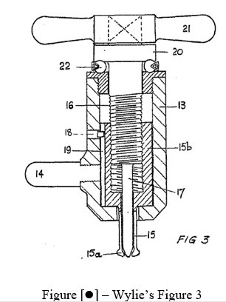
- The tommy bar 21 is attached to a cap 20, which is attached to a screw 16. A ball-race 22 is located between the cap and the body to reduce friction. There is a split-sleeve 15 in two parts: a wide portion 15b with an internal thread to receive the screw and a narrow portion with a reduced bore at its head 15a. The tommy bar is rotated and with it the screw so that the split sleeve is drawn up into the body 13. The body is prevented from rotating by use of the projecting handle 14. The split-sleeve is prevented from rotating relative to the body by a key and keyway 18 and 19. Attached to the bottom end of the screw there is a mandrel 17.
- The rotation of the screw causes the split sleeve to move upwards. Its head 15a is drawn over the tapered end of the mandrel, forcing the arms of the split-sleeve to expand radially outwards. The workpieces (not shown) are located between the head of the split-sleeve 15a and the base of the body 13. As the radially expanded arms of the split sleeve move up, they are forced against the lower surface of the lower workpiece. The two workpieces become clamped between the heads of the sleeve arms and the base of the body.
- The specification explains the release of the fastener (referred to as a “clip”):

“In order to release the clip the screw 16 may be unscrewed so as to lift the cap 20 away from the ball race 22 leaving the sleeve in position until the end of the mandrel is clear of the reduced bore of the sleeve thus permitting the head of the sleeve to contract so that the clip may be removed.”
- The split-sleeve may be split into two parts, so that there are two arms which move apart when the head is pulled over the mandrel. Alternatively it may be in four parts, providing four arms (the putative fingers). Figure 2 shows the latter embodiment in cross-section:

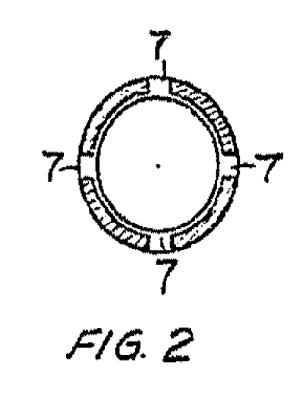
- By the time of closing argument Kwikbolt had three points, two of them directed to claim 1. The first was based on the cap and the screw moving upwards during removal while the sleeve and the body remain in position. Mr Vanhegan put it this way in closing:

“So, it is common ground between the experts that Wylie does not disclose the device being removed as a unit after it has been used to clamp.”
- That is not at all what either Mr McKay or Mr Jack said. Mr McKay conceded expressly in cross-examination that the fastener was removable as a unit. He accepted that the reference to the sleeve staying in position until the end of the mandrel is clear of the reduced bore of the sleeve meant only that the sleeve cannot be pulled clear of the workpiece until the arms have moved radially inwards sufficiently.
- At the end of a sustained passage of cross-examination Mr Jack confirmed that the sleeve stays in place until the mandrel is clear of the reduced bore of the sleeve. In my view he was saying the same thing as Mr McKay, which was that once the arms of the sleeve have moved radially inwards, the entirety of the fastener is removed – as a unit.
- Mr Vanhegan’s second point concerned the same passage of the specification – that quoted above concerning the removal of the fastener. He submitted:

“That means that on removing the screw, the second member does not slide relative to the first member whilst simultaneously reducing the radial extent of the finger ends. That is what is required by features 1.15 and 1.16 of the Kwikbolt patent … as accepted by Mr Jack.”
- Mr McKay did not provide an explanation as to how the Figure 3 fastener could operate unless there were relative motion between the first and second member during removal – in other words, that during removal the sequence of events during insertion is reversed. Mr Jack said that it could not. That makes sense and I accept Mr Jack’s evidence.
- Before leaving claim 1 I have to consider integer 1(1) – whether Wylie is a removable fastener according to the construction of “removable” that I have found – and integer 1(8) since I have found against Kwikbolt on the construction of that integer.
- As to integer 1(1), there is no doubt that the Wylie fastener can be removed in the manner discussed in the passage from Wylie I have quoted above. That passage is immediately followed by this:

“In such a clip considerable friction takes place between the sleeve and the mandrel and it is advantageous to form both of very hard metal in order to minimise the wear that would otherwise take place.”
- In his first expert report Mr McKay said that he would expect the friction identified in that passage of Wylie to be caused by the use of a sleeve that has a small clearance in the hole, as described with reference to Figure 1. When discussing Figure 1 Wylie says:

“The hole in the articles [the workpieces] is of a size just to permit the passage of the head of the contracted sleeve.”
- Mr Jack agreed in cross-examination that in the passage of Wylie I have just referred to the reader is being told that a lot of force is required to force the metal of the split sleeve out of the panel members.
- Wylie contains no clear and unmistakable direction that the fastener is removable in the sense that it may be removed without damage to the fastener or the workpieces. However, Wylie does not suggest that the tight fit of the split sleeve in the apertures of the workpieces is of significance to the invention described. Nor did either expert. It seems to me that it would have been obvious to the skilled person at the priority date of the Patent that the Wylie fastener could be used with workpieces having an aperture of a diameter such that the split sleeve fits less tightly so that the fastener could be removed without damage to the fastener or workpieces.
- I turn to integer 1(8). This seems to have become lost in the experts’ analysis of Wylie. On Kwikbolt’s construction of integer 1(8) the screw head (the cap and tommy bar) is indeed adjacent the first member head. In consequence, Kwikbolt conceded that this integer was present in Wylie and matters seem to have been left there by both experts. But this concession rests on the head of the first member being at the top of the first member and thus adjacent the cap. I have found that the head of the first member is whichever end it is that bears against the top workpiece. As represented in Figure 3, that is the bottom of the first member. It follows that the head of the first member is not adjacent the screw head, namely the cap and tommy bar.
- I find it impossible to conceive how Wylie could be made to work with the cap and tommy bar adjacent the end of the first member which bears against the top workpiece. Claim 1 is not obvious over Wylie.
- Mr Vanhegan’s third argument concerned claim 8. Claim 8 is dependent on claim 1 so it cannot be obvious, but I will address the argument. It was that Figure 3 of Wylie does not disclose planar finger heads. Claim 8 requires that each finger head provides a planar surface to engage with a planar surface of a workpiece to prevent damage to a workpiece. Mr Vanhegan conceded that the Figure 1 embodiment of Wylie was shown as having planar finger heads but submitted that it was not obvious to introduce these into the Figure 3 embodiment. He supported this by evidence from Mr Jack that Wylie was an old disclosure, multi-component and expensive and unlikely to be suitable for automation in use, which was the focus of attention at the filing date.
- Even if a piece of prior art is old, the hypothesis is still that the skilled person will read it with care at the filing or priority date. If an obvious modification to the prior art would occur to the skilled person, such a modification is not taken out of consideration for inventive step solely because the skilled person would believe that modified or not, this old piece of prior art would have little practical or commercial use as of the filing or priority date.
- Mr McKay accepted in cross-examination that at the filing date, if the skilled person wanted to use the Figure 3 embodiment for composites, he or she would use flat fingers to spread the load so as to avoid damage. I agree with Mr McKay that taken alone this would have been an obvious modification for fastening materials that were not hard enough to resist distortion.

Conclusion on Validity
- The Patent lacks neither novelty nor inventive step over any of the cited items of prior art.

Insufficiency
- There was a pleaded argument of insufficiency that was based on what seems to me to be an over reliance on a diagrammatic representation of the invention claimed as shown in Figures 3A and 3B. As I discussed earlier, the two workpieces are shown to be at a distance from each other without any bracing between them. Taken literally, as soon as a clamping force was applied, they would collapse towards each other. But by the end of cross-examination both experts treated Figures 3A and 3B as schematics, not to be taken literally, agreeing that the skilled person would be fully capable of implementing the invention claimed. The insufficiency argument fails.

Overall Conclusion
- The Patent is valid but is not infringed.

