IN THE HIGH COURT OF JUSTICE
BUSINESS AND PROPERTY COURTS OF ENGLAND AND WALES
PATENTS COURT (ChD)
SHORTER TRIAL SCHEME

Rolls Building
New Fetter Lane
London

Neutral Citation Number: [2019] EWHC 3175 (Pat)
Date: 21 November 2019

Before:

HER HONOUR JUDGE MELISSA CLARKE
sitting as a Judge of the High Court
- - - - - - - - - - - - - - - - - - - - -
B E T W E E N :
Claim No: BL-2018-000034

 | EXCEL-EUCAN LIMITED | Claimant
 | - and -
 | SOURCE VAGABOND SYSTEMS LIMITED  (A Company incorporated in Israel) | Defendant

- - - - - - - - - - - - - - - - - - - - -
- - - - - - - - - - - - - - - - - - - - -

Mr Andrew Lomas (instructed by Michael Markham, Solicitor) for the Claimant
Mr Ben Longstaff (instructed by Asserson Law Offices) for the Defendant

Hearing dates: 16 and 17 July 2019
- - - - - - - - - - - - - - - - - - - - -
APPROVED JUDGMENT

Her Honour Judge Melissa Clarke:

INTRODUCTION
- This dispute relates to a carrier for machine-gun ammunition.
- Both parties are manufacturers of military equipment. The Claimant (“Excel”) holds UK Patent Number GB2489116 for an ammunition bag named the “Link-Tail”, granted on 1 March 2017 (“GB’116”). The Link-Tail is designed for holding linked rounds of ammunition in the form of bullets mounted onto a long piece of webbing or similar material, such as to allow them to be fed easily into a machine gun.
- Below is a photograph of the Link-Tail in use (laid on the ground), from which can be seen the linked ammunition being fed straight from the bag into the gun, with the webbing-side up (Image 1):

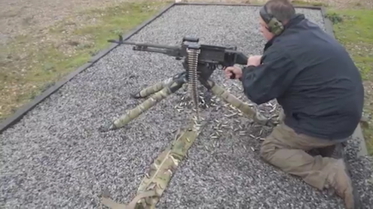
- Excel entered into a patent licence agreement with the Defendant (“Source”) on 12 February 2015 in respect of the Link-Tail (“Licence Agreement”). Pursuant to the Licence Agreement, and up to around the end of 2016, Source manufactured and supplied a slightly amended version of the Link-Tail (the “Source Ammunition Bag”) to the UK Ministry of Defence (“MoD”) as part of a large-scale procurement exercise known as Project Virtus (“Virtus”), and paid Excel a fixed royalty per unit sold on all such sales. It is not disputed that Excel cannot supply into Virtus directly. It can only do so through the MoD prime contractor for Virtus, which is Source. The Licence Agreement contains no positive obligation on Source to supply the bags to the MoD, nor to pay Excel any minimum sum in royalties, nor does it provide any guarantee of minimum sales.
- In February 2014 Excel filed and was granted another patent for a further development of the Link-Tail with an added “adjustment strap” (“GB‘562”).
- This dispute arose because in December 2016 (and again in February 2017) the founder and director of Excel, Mr Robert Maclean, sent an email to the MoD raising what he perceived as quality issues with the Source Ammunition Bag. Source came to learn of the email, and instructed its lawyers to write to Excel contending that by sending the email, Excel had repudiated the Licence Agreement and this was incompatible with it continuing in force. Accordingly, Source purported to terminate the Licence Agreement.
- Meanwhile, Source developed its own design of bandolier-style ammunition bag in early 2017 (“the 2017 Bag”), which it proposed to supply to Virtus in place of the Source Ammunition Bag, having gone through an MoD evaluation process so to do. Excel claim that the 2017 Bag is based on the Link-Tail and is an immaterial variant of it, falling within the footprint of GB’116. In addition, even if it does not fall within the footprint of GB’116, it has been created by Source by the use of Excel’s Licensed Know-How (as defined in the Licence Agreement). In either case, Excel claims, the 2017 Bag is royalty bearing pursuant to the Licence Agreement. Source says that the 2017 Bag is a new creation inspired not by the Link-Tail but by a bandolier ammunition bag used in the British Army in the 1980s, and known as “the Q33A”.
- The below photograph shows the Link-Tail (top) and the Source Ammunition Bag (below) (Image 2).

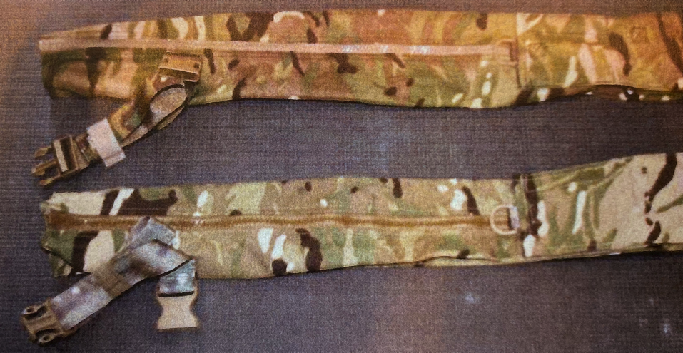
- The below photograph shows the Q33A (left); the Link-Tail (middle); and the 2017 Bag (right); in each case with the top flap open (Image 3):

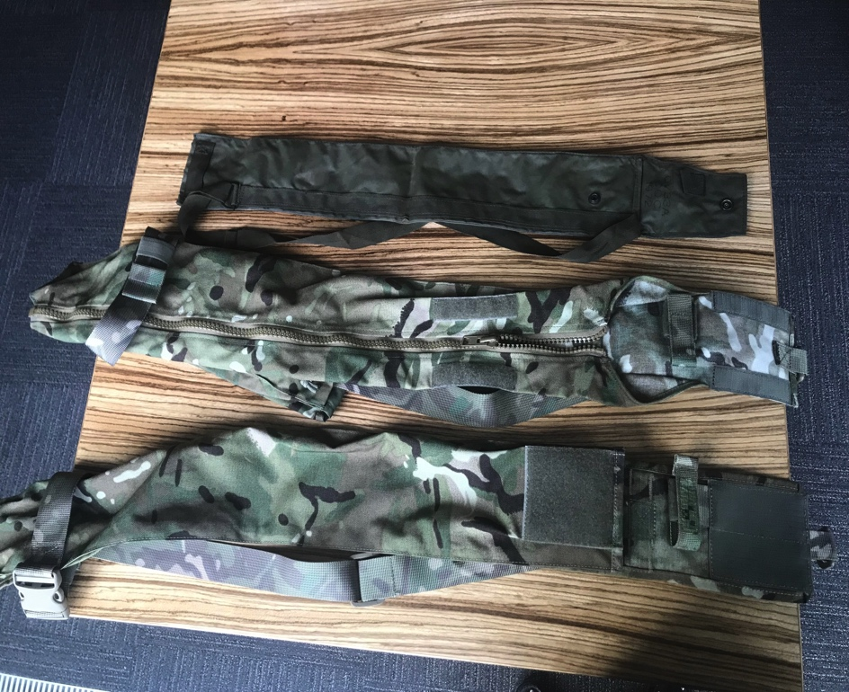

- The Link-Tail and the 2017 Bag, although similar, can be quickly distinguished because the Link-Tail has a zipped opening running down the length of it and the 2017 Bag does not. Nor does the Q33A. The Link-Tail and the 2017 Bag also have a somewhat different shape in cross-section. The Link-Tail is a rounded triangle and the 2017 Bag is flat with side gussets. This can be seen in the photograph below which shows the reverse of the 2017 Bag (left) and the Link-Tail (right) (Image 4):

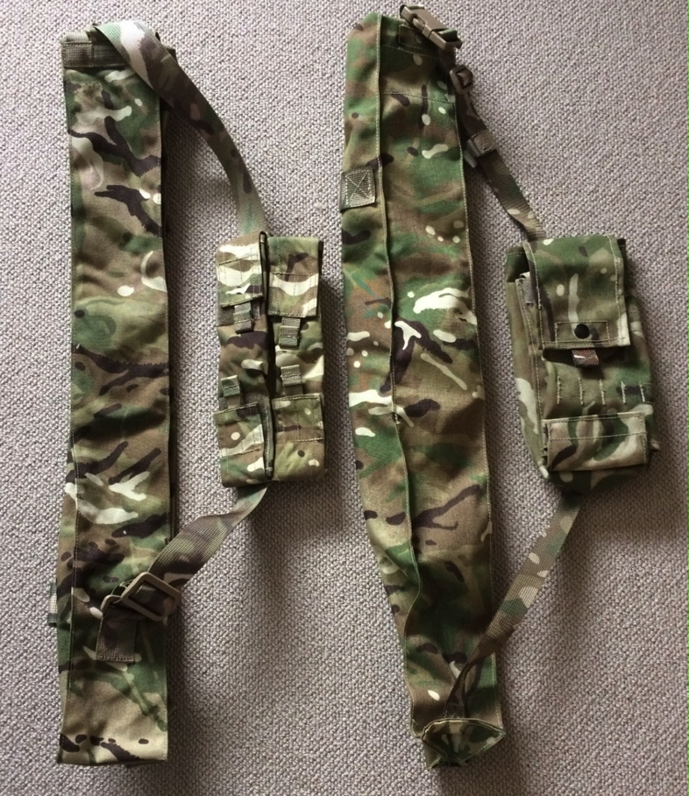

PROCEEDINGS
- In January 2018 Excel issued this claim for:
  - A declaration that the Licence Agreement remains in force and was not repudiated by any action of Excel;
  - Unpaid royalties and/or damages for breach of contract. Excel no longer asserts any positive case that royalties are outstanding. Instead it seeks damages for breach of contract by, inter alia, the purported wrongful termination of the Licence Agreement;
  - Contractual costs.
- Source defends, and counterclaims for:
  - A declaration that the Licence Agreement was repudiated by Excel and properly terminated by Source. However, very shortly before trial, by an open letter from Source to Excel of 4 June 2019, Source abandoned its case that Excel had repudiated the Licence Agreement and, in consequence, accepted that the Licence Agreement had always been and remained in force. Accordingly it no longer seeks this declaration;
  - A declaration that the Licence Agreement was not enforceable absent a valid patent. However, Source abandoned this aspect of the counterclaim after service of the Re-Amended Defence and Counterclaim and so no longer seeks this declaration;
  - A declaration of non-infringement of GB’116 and GB‘562 by the 2017 Bag. This remains in issue;
  - A declaration that the 2017 Bag is not royalty bearing. Source’s original case on this point was that only variants that fall within the footprint of GB’116 are royalty bearing, and its case is that the 2017 Bag does not infringe GB’116. However, at trial, Source accepted that as a point of contractual interpretation it is possible for the 2017 Bag to be royalty bearing pursuant to the Licence Agreement, even if it does not fall within the footprint of patent GB’116. Source’s case that the 2017 Bag is nonetheless not royalty bearing remains in issue.
- In the Re-Amended Reply and Defence to Counterclaim, Excel:
  - Admits that the 2017 Bag does not infringe GB’562;
  - Maintains that the 2017 Bag is an improvement or alteration of the “Licensed Products” under clauses 3.3 and/or 5 of the Licence Agreement, such as to be royalty bearing.
- While these proceedings were afoot, in February 2018 Source commenced revocation proceedings in the UKIPO against both patents, GB’116 and GB’562. In response to the IPO’s preliminary indication of invalidity of GB’116 on 16 November 2018, Excel applied unconditionally to amend the claims of GB’116. The parties agree that validity of the patents is not in issue in these proceedings, being a matter for the freestanding applications in the UKIPO. However, they would like this Court to determine the non-infringement issue as against the amended claims in GB’116, and in doing so, for the purposes of that determination only, assume the validity of GB’116.

ISSUES
- The parties agree that the issues which remain to be determined by this Court are:
  - whether Source is entitled to a declaration that the 2017 Bag does not infringe the amended claim in GB’116;
  - whether or not the 2017 Bag is royalty bearing under the Licence Agreement; and
  - whether Excel is entitled to an inquiry as to damages.
- It is common ground that Source bears the burden of proof in respect of the first issue as it seeks a declaration of non-infringement, and Excel bears the burden of proof in respect of issues 2 and 3. The civil standard applies.
- Should it transpire that Excel is, ultimately, the successful party in these proceedings, it gives advance notice of a fourth issue, namely: Whether and to what extent Excel can recover the costs of this action and the UKIPO proceedings under the contractual indemnity contained in Clause 10.2 of the Licence Agreement.

WITNESSES
- The Claimant’s witnesses are:
  - Mr Robert Maclean, the founder and director of Excel and inventor of the Link-Tail. He filed two witness statements and was cross-examined and re-examined. Mr Longstaff for Source expressed no criticism of his evidence and I found him to be a straightforward, professional, credible and reliable witness. I thank him for his attendance at trial to give oral evidence so shortly after the sad loss of his father.
  - Mr Andy Lynch. He filed a short witness statement and Source elected not to cross-examine him. Accordingly his evidence is not disputed.
- The Defendant’s witnesses are:
  - Mr Yoki Gill, co-founder and Managing Director of Source. He has filed one witness statement. He intended to attend court to give oral evidence at trial, but unfortunately his mother was taken very seriously ill and so he was unable to do so. Source filed a civil evidence act notice in respect of his evidence. Much of his evidence overlaps with that of Mr Clee, albeit not all of it. Much is also documented in contemporaneous correspondence. However, undoubtedly there are questions that Excel would have liked to have asked him if he had been able to attend, and I have not had the benefit of seeing him give oral evidence, which might have assisted me in assessing his credibility. For those reasons I give those aspects of his evidence which are disputed and not supported by other credible and reliable evidence commensurately less weight.
  - Mr Charles Clee, a former Colonel in the British Army who now runs a consultancy assisting private clients wishing to work in the defence and humanitarian sectors. He worked with Source to help it become prime contractor for Virtus. He was cross-examined and re-examined. I also found him, like Mr Maclean, to be straightforward, professional, credible and reliable. Mr Lomas submits that Mr Clee’s admission that he may have required, but did not obtain, an export licence to send to Source in Israel a sample of the Link-Tail which he had bought on eBay should damage his credibility in the eyes of the Court as it shows that he has “played fast and loose without regard to how things should be done”. The questions are whether such an export licence was required at the relevant time, which was shortly before changes in the regulations which the parties accept now provide that such equipment does not require an export licence, and, if so, whether Mr Clee knew that it was. It is not a question that I need to determine, in my judgment. If Mr Clee was in breach of export licence requirements then of course I do not condone it. However I accept that if he was, he did not breach them knowingly and I do not think it adversely affects my assessment of his credibility when giving evidence under oath in this court. Nor do I consider it appropriate to accept Mr Lomas’s invitation to use that conduct, if any, as a prism against which Source’s conduct should be viewed.

THE FACTS
- Mr Maclean was a Royal Marine from 1986 until 1993, during which time he became a qualified Royal Marine Sniper Instructor. After leaving the forces, he became a consultant to Defence companies in the UK and Middle East.
- In December 2011 the MoD published contract notice details of a competition called URBEX 2012 which was intended to identify and evaluate commercially available, off the shelf, high readiness equipment, capable for use in dismounted close combat in complex terrain. The competition intended to carry out demonstrations, tests and trials of such equipment to find equipment that would de-risk and directly support HM Forces’ urgent operational requirements.
- One of the categories of equipment sought was “TM4: Rapidly accessible linked ammunition stowage suitable for 200 rounds of 7.62mm”. Mr Maclean explains that this is ammunition primarily used in the UK and NATO Armed Forces to feed a fully automatic general-purpose machine gun (“GPMG”). He says that in the context of dismounted close combat (i.e. soldiers fighting on foot dismounted from any vehicles), each section (a group of 8 soldiers) would be expected to carry one GPMG between them, with most soldiers expected to carry 7.62mm ammunition to feed the weapon given its rapid rate of fire.
- Mr Maclean’s evidence is that he discussed the TM4 requirement with a number of ex-servicemen and came to the conclusion that there had never been a piece of issued equipment to meet this requirement. Instead, ammunition was either stowed in a sand bag in the soldier’s rucksack, and had to be entirely removed from both the rucksack and the sand bag before firing; or it was stored in and fired directly from the heavy steel container in which it had been issued from stores. Mr Clee offers a third example: that in the 1970s and early 1980s linked ammunition was stored in the Q33A bag which could be worn bandolier-style, but which also required the ammunition to be entirely removed from the bag before firing.
- Mr Maclean says he set about to design a piece of equipment to meet the following criteria:
  - Light weight, low bulk, low cost;
  - Ease of use;
  - Ability to directly feed the ammunition into the weapon system;
  - Snag-free delivery of the ammunition;
  - Easy and quick resupply of ammunition to the gunner;
  - Protection of the ammunition from contaminants (dirt, stones etc.) as these are the majority of weapon stoppages.
- In relation to point (iii) above, his evidence is that although this requirement was not stipulated in the URBEX 2012 notice, he wanted to develop a “plug and play” product.
- Mr Maclean experimented with 7.62mm linked ammunition rounds, in which the bullets are connected by metal links on one side, leaving the brass of the ammunition casings exposed on the other. They are fed into the GPMG link-side up, as can be seen in Image 1 above. He says that he determined that, provided the ammunition was layered underside to underside, or brass-to-brass, when fed through the machine gun, the ammunition would easily flow freely across itself, without snagging.
- He then turned his mind to “identifying a shape which would optimise ease of carriage coupled with the target characteristics of lightweight, low bulk and low user burden” and concluded a tubular profile would offer optimum results, in particular because the ammunition lays flat within it, which he says: (i) was the correct positioning to allow uninterrupted delivery to the weapons feed tray; (ii) could be worn by the user in the style of a cummerbund, around the waist; (iii) could be laid across the top cover of the GPMG, leaving the carry handle of the machine gun exposed to be manoeuvred as required; and (iv) enabled easy loading of, and access to, the ammunition. In fact the triangular profile of the Link-Tail is not mandated in GB’116, as the specification makes clear. It specifies that a flatter profile may be preferred, as long as it has the volume to take the ammunition required.
- In addition, Mr Maclean describes that he: added a loop to secure the first round of the linked ammunition by the top opening, so it could be easily accessed to feed into the GMPG without the need for the user to look down and find it; and tapered the top opening outwards to ensure the ammunition was not restricted when being drawn into the weapon.
- Once the final design was completed, Mr Maclean applied for the patent, which was eventually granted as GB’116, gave the designed product the name ‘Link-Tail’ and submitted it into the URBEX 2012 competition. The Link-Tail passed through all stages at URBEX 2012 and was positively evaluated. The report summarises it as a cost effective, lightweight, link stowage solution which allows the link to be stored away from dust and grime and allows snag-free feeding direct from the bag. It identified that it reduced the chance of misfeeds from twisted ammunition and enabled resupply of link from other members of the squad to the machine gunner with more speed and ease. Ease of use was noted as being excellent, however it noted that care was required in loading the link to ensure that the link was presented to the gun correctly, i.e. link side up. It noted that a hand drawn marker pen diagram inside the link tail helped unfamiliar users to ensure the link was loaded the correct way first time, so suggested that a clear diagram be added to the product. It also suggested that a strap be added to enable it to be carried bandolier-style.
- Following URBEX 2012, the Commanding Officer of the Infantry Trials and Development Unit (“ITDU”) took samples of the Link-Tail to Afghanistan for evaluation and testing in-theatre. Excel added to these samples a marker patch of the type recommended by the URBEX 2012 report. Afterwards, Mr Maclean was told in an email from the URBEX 2012 Manager that “Results have been very positive and limited follow on procurement action is now planned (without commitment / without prejudice)/ I have supplied your POC details to Personal Combat Equipment (PCE) Project Team… and Theatre… for action”.
- In early 2013 Mr Maclean became aware of MoD’s Project Virtus, the stated aim of which was to completely replace all of the various component pieces of the soldier man worn system (equipment, webbing, load carriage and armour) with a fully integrated soldier system (“ISS”). In February 2013 he attended the Virtus Industry Day during which he was told that “the Link-Tail is part of Virtus”. At the end of the Virtus Industry Day, he was provided with a copy of the draft System Requirement Document (“SRD”) for Virtus, in which he found that category SRD 338 sought a system that could:
  - Facilitate the carriage of linked ammunition;
  - Securely hold and protect ready for use 200 rounds of 5.56mm or 7.62mm linked ammunition;
  - Allow ammunition to be fed onto the feed tray of a weapon system directly from the load carrying system;
  - Allow ammunition to be readily available and carried over the shoulder similar to a bandolier.
- Mr Maclean’s evidence was that it was clear to him that the requirement was describing the Link-Tail, and the key features described were those which he had designed and which were highlighted in the URBEX 2012 report following evaluation and testing by ITDU. The only difference was that the SRD envisaged it being carried bandolier-style over one shoulder rather than as a cummerbund or in a rucksack or daypack. Mr Maclean determined that this could be managed by a minor change to the design to add a tensioning strap to prevent pooling of the ammunition in the base of the Link-Tail (see Image 5 below). This modified design is the basis for what became GB’562.

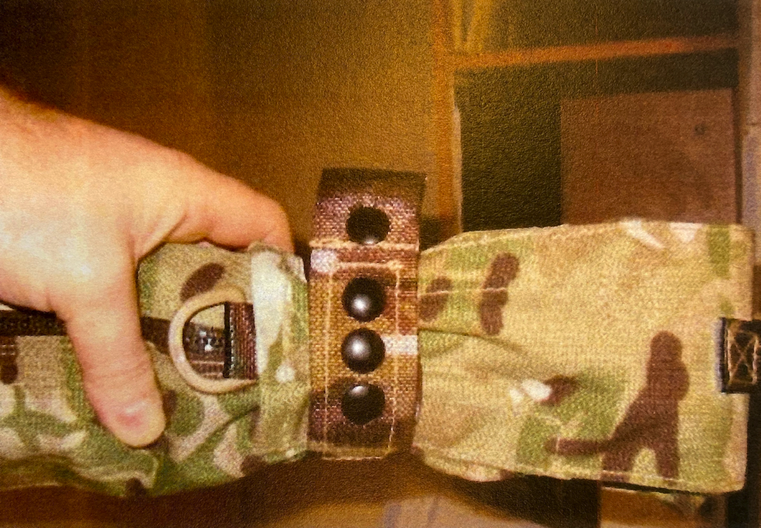
- Mr Maclean learnt that Virtus would be procured by the MoD via a single Prime Contractor. On 13 September 2013, the MoD published the list of four companies invited to tender for this role. One of them was Source. Excel contacted all of them by email offering the Link-Tail as a solution to meet SRD 338. The other three responded quickly and Excel entered into NDAs with them and their respective manufacturers.
- Mr Ronny Arazi, the CEO of Source, telephoned Mr Maclean on 1 October 2013. They discussed the Link-Tail and Mr Maclean emailed him some marketing materials about it. Although Mr Maclean sent a chasing/follow-up email in early December 2013, Source did not contact him again until 17 December 2013, when Mr Maclean received an email from Mr Gill, who introduced himself as managing the Virtus submission for Source. He said: “We have developed already our link ammunition pouch for Virtus. Saying that and based on your saying that the user population accepted your product I will be willing to consider your product for our submission”. He requested a copy of the GB’116, which Mr Maclean forwarded to him the same day.
- Mr Clee confirms that the reference in Mr Gill’s email to ‘the user population’ is a reference to the testing, evaluation and use that the Link-Tail had already received from the MoD and in theatre. Mr Clee’s evidence was that the process of getting equipment approved by the MoD was not trivial, and that Excel had done well to have had Link-Tail approved, and included within Project Virtus. He confirmed Mr Maclean’s understanding that such an item of equipment was not part of Virtus originally and that SRD 338 was added because of the positive evaluation of Link-Tail by ITDU.
- Mr Maclean is doubtful that Source had in fact produced their own design in December 2013 which met the SRD, in relation to which Source has disclosed no drawings or other evidence of its development. Excel poses the question: Why would Source have used the Link-Tail if it had already developed its own solution?
- In his witness statement, Mr Gill says that at the time he contacted Mr Maclean, “Source had practically completed the design of its own linked ammunition pouch and intended to supply this product as part of its ISS trial sets. However, Mr Maclean claimed that his product had already been tested by the MoD and deployed operationally. If Source incorporated Mr Maclean’s pouch rather than its own, it could rely on this previous testing and approval and thereby gain certainty that the MoD would approve of the product”. He also noted that Source was under immense time pressure since the full system had to be submitted within the next few months. In my judgment these are both good reasons for using the Link-Tail even if it did have its own solution almost ready to go. Mr Gill’s evidence is also supported by contemporaneous documentation: Mr Gill wrote to Mr Maclean at this time saying “I have read carefully your patent and I do not think our design infringe [sic] your patent. However the merit I see here is not in your design but in the work you did with the UK MoD to accept your product. This on its own for us as Prime who deals with a multi component system and seek to have no failure has value.” Excel also asks why would it have developed the 2017 Bag from the Q33A (as is Source’s case) rather than revive its December 2013 almost-completed solution, if such a solution existed? Mr Clee in oral evidence explains that at the end of 2016 Source needed a new solution to answer user difficulties with the Link-Tail/Source Ammunition Bag, and it couldn’t use the previously Source- developed solution, as it was not similar enough to the solution the MoD had already approved. Source didn’t want to offer a major substitution which would need to undergo extensive testing from scratch. I accept that it didn’t want to offer a major change, and will return to this later in the chronology. On considering all the evidence I am satisfied that it is more likely than not that Source did have an ammunition bag to meet SRD 338 in advanced development in December 2013, but preferred to use the Link-Tail for the reasons Mr Gill gives.
- On 10 January 2014 Mr Gill sent Mr Maclean the following email:

“Can you please send me two final samples of your VIRTUS Link-Tail (including the additional side pouches for stowing x2 Para flares and 8x cyalume sticks). My plan is to test the function of your product once received (including live shooting) and compare it with our design. If we will find your product equal or better in performance then our design, we will follow with a royalty agreement of [redacted] GBP per unit. I will share our test results with you.”
- Mr Charles Clee telephoned Mr Maclean on 14 January 2014 and introduced himself as the UK agent for Source. He asked for a copy of the URBEX trials report and more detailed information on the Link-Tail, which Mr Maclean sent him. This included numerous photographs of the Link-Tail. Mr Maclean noted on his email that the photographs did not show “an additional modification” but said he would provide details of it if Source wished to produce its own samples, subject to first entering into “some form of contractual agreement”. He was referring to the tensioning/adjustment strap to prevent the horizontally flaked rounds slumping when the Link-Tail was carried bandolier-style. He also told Mr Clee: “The only weakness that was identified [in the URBEX 2012 trial] was the need for ‘care in loading’. Subsequently we incorporated a marker patch (this will become evident when you view the user instructions attached). In my opinion this is a training issue, much the same as loading rounds into a magazine. Provided you place the rounds as depicted on the patch you CAN NOT load the Link-Tail incorrectly”.
- The next day Mr Clee telephoned him and told him that he had purchased a Link-Tail on eBay, as a sample, and dispatched it to Source in Israel.
- Mr Gill’s evidence is that he and his design team evaluated the sample purchased on eBay, and noted that the Link-Tail “allowed for the ammunition stored in the bag to drop to the bottom of the bag when the bag was carried over the shoulder. This meant that when the user wished to load the ammunition… they would find that they could not as the lead round of ammunition had dropped to the bottom of the bag. …To remedy this issue our design team incorporated a Velcro strap or loop for attachment at the top of the Link-Tail into which the top round of ammunition could be secured.” In fact I am satisfied on the evidence before me that there was already a first-round retaining loop on the Link-Tail purchased by Mr Clee on eBay and so this was not a design feature added by Source. However in oral evidence Mr Clee confirmed that he did not think the sample he purchased from eBay contained the marker patch indicating the correct method of loading the linked round and I accept that evidence.
- On 31 January 2014, Mr Gill emailed Mr Maclean to say that he was “inclined to take the direction of using your Link-tail design and sign the royalty agreement we discussed”. Source and Excel entered into an NDA on 18 February 2014 following which Mr Maclean forwarded by email six images of the adjustment strap modification to the Link-Tail, together with a document explaining the purpose of it. Image 5 (above) is a detail from one of those images.
- Mr Gill emailed him on 22 February 2014, saying:

“We have already made our own design changes for 5.56/7.62 rounds and shorter length of belt as we have identified these problems in the link tail purchased on eBay… I will provide you images of the amendments we made on your product after submission date. Right now, I am trying to keep our designs out of the reach of our competitors. Please send me your proposed royalty agreement draft based on what we agreed. Let’s sign it and get this action item behind us”.
- In his witness statement, Mr Gill says that he didn’t see much value in the adjustment strap as he believed that the problem had been fixed by the addition of the Velcro strap or loop for the attachment of the first round. As I have found, the first round attachment was not an addition by Source, and in my judgment this displays Mr Gill’s failure to understand the purpose of the adjustment strap. On 4 April 2014 Mr Gill told Mr Maclean by email that Source had made “significant changes to your design in order for it to be able to integrate with the system – making what we have submitted a different product”. Mr Maclean asked for images, which Mr Gill sent. Mr Maclean did not notice that there was no adjustment strap present, and the photographs he was sent did not include the underside of the top flap, so did not enable him to identify that the marker patch was also missing. Mr Clee in oral evidence accepted that there were no significant changes save for the deletion of the adjustment strap, nor any changes which were required for it to integrate with the wider ISS system. I am satisfied on the balance of probabilities there were no significant changes in the design of the Source Ammunition Bag to the design of the Link-Tail.
- Source submitted its ISS system, including the Source Ammunition Bag, to the MoD for evaluation to Virtus in April 2014. On 22 January 2015 Mr Arazi informed Mr Maclean that Source had been awarded the Virtus contract as prime contractor. Mr Arazi said: “Despite the fact that the item is different from your original design, we would like to adhere to what was agreed between you and Yoki [Gill]. I therefore ask that you will review the attached [draft licence agreement], that was originally sent to you last April, and revert”.
- There then followed a period of discussion and negotiation between Mr Maclean, Mr Clee and Mr Arazi. The Licence Agreement was entered into on 12 February 2015.
- Source began to deliver Virtus equipment in September 2015. Mr Maclean saw a physical example of the Source Ammunition Bag for the first time on 17 September 2015 at the Defence and Security Exhibition in London. He noted that Source had not incorporated the retaining strap or the marker patch, and was concerned to see that the Ammunition was incorrectly loaded in the Source Ammunition Bag on display. Mr Clee in oral evidence said that he didn’t know whether Source had ever affixed a marker patch on the Source Ammunition Bag (although it affixed a marker patch very similar to that used by Excel on the Link-Tail to the later-produced 2017 Bag). I accept there were none on the version displayed at the defence exhibition or photographed for the training materials.
- Mr Maclean emailed Mr Arazi on 22 October 2015 asking for samples of the Source Ammunition Bag and a copy of the training documents produced by Source. When he received them, he was concerned to note that in Source’s instruction leaflet, inter alia, two of the three photographs showed the ammunition loaded the wrong way up, i.e. brass-side up, not link-side up, as was required for proper delivery to the gun. See Image 6 below:

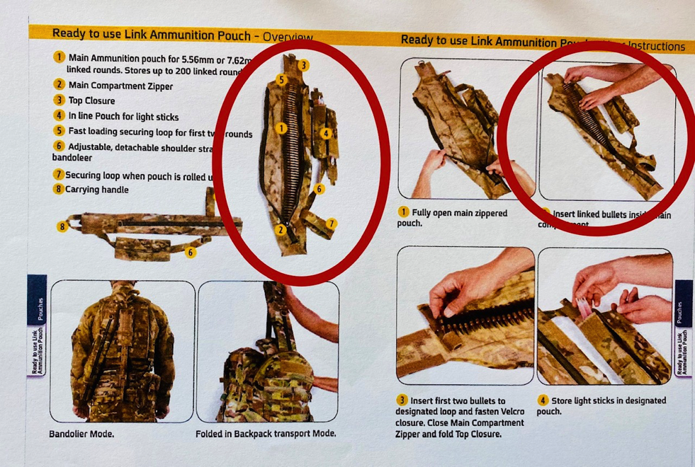
- Mr Clee accepted in cross-examination that these photographs were wrong, that a user who followed them would load the ammunition incorrectly, and it appeared that users were being taught how to load the ammunition incorrectly by Source’s sub-contracted trainers, Falco-P.
- This discovery broadly coincided with information provided to Mr Maclean by Andy Lynch, who had spoken to soldiers training in Northumberland using the Source Ammunition Bag, that they were unsatisfied with it because of feed issues. As Mr Maclean states in his witness statement: “I became seriously concerned that not only was the product incorrect and missing two vital components (the strap and the marker patch) but also that the training literature was teaching users to load the ammunition back to front, which would have become apparent if the marker patch was present”. He emailed Mr Clee with his concerns but received no response. Accordingly he sent an email to ITDU on 16 December 2016 setting out his concerns and offering to modify the Source Ammunition Bags already in service by addition of the patch and the tensioning strap. When he received no response, he sent the same email to a friend in the Defence Ordnance Safety Group asking for it to be forwarded to ITDU. These are the emails that Source has objected to, and which catalysed this dispute.
- Mr Gill says that in or around November 2016 he was told by Mr Clee that units were not fully utilising the Source Ammunition Bag and that it was often loaded or used incorrectly because soldiers were not properly placing the ammunition into it. This information arose as feedback from a field exercise with the 2nd Battalion Parachute Regiment. In his witness evidence, Mr Gill attributes this to the zipper design, which he says meant that users needed to ensure that they laid the non-feed end of the linked ammunition into the Source Ammunition Bag first, and starting at the open end, and then fold the ammunition back over itself to ensure that the feed end of the ammunition ended up at the top of the bag so it could be fed into a weapon. He says “users found this non-intuitive” and occasionally loaded the ammunition into the bag so that the non-feed end of the ammunition ended up at the top of the bag, which was incorrect.
- Mr Gill’s wording is exactly mirrored in Mr Clee’s witness statement. Mr Clee accepted in cross-examination that there is no evidence to support the statement that “users found this non-intuitive”. He accepted that the problems may have arisen from the faults with the training and instruction leaflet, and the absence of a marker patch. He accepted that a marker patch on the Source Ammunition Bag would have been even more helpful, given the inadequacies of the training and instruction leaflet. I remind myself that the feedback from the URBEX 2012 trial was that users found the loading simple, but benefitted from a marker patch to show which way around the linked round should be loaded.
- I find that it is more likely than not that the reported failure of users to load the Source Ammunition Bag correctly was not because of the presence of the zipper or the recommended method of horizontal flaking the round directly into the bag, but because: (i) there was, on the balance of probabilities, no marker patch giving a simple visual confirmation that the feed end should be link-side up; and (ii) the training document showed the ammunition bag incorrectly loaded, likely causing confusion both with users and potentially also with Source’s trainers, who were using that document to train units. Accordingly I accept Mr Maclean’s evidence that this was a training issue and could have easily been resolved by an addition of the recommended marker patch to the Source Ammunition Bag, and corrected training documents.
- Mr Clee’s evidence is that he was informed in late 2016 by Mr Pete Hewkin, the MoD trials manager for Virtus, that ammunition could easily be loaded into the Source Ammunition Bag when it was held vertically by dropping the lined round through an opening in the top of the pouch, rather than laying it horizontally through the full-length zipper. Philip Gregory, a former Royal Marine platoon weapons instructor, started a piece of work to look at the process of simplifying the bag. Source relies on two test videos produced by Mr Gregory’s colleague, showing the new vertical loading technique, but these used a zipped up Link-Tail to demonstrate it. These show that the Link-Tail loaded in this manner without the use of the zip enabled ‘plug and play’ firing of the linked round in a similar manner as the horizontal loading technique.
- Mr Gill says that, accordingly, Source set out to design a new ammunition pouch in which the ammunition was loaded from the top, eliminating the vertical zipper which was no longer required, and with a flatter, rectangular shape rather than the triangular shape of the Link-Tail and Source Ammunition Bag, to reduce the possibility of the ammunition twisting and causing feeding jams.
- Mr Clee calls this a “re-think of the entire design of the ammunition pouch… which eliminated the triangular shape of the bag by removing the zipper”. He said that he recommended that Source adapt the Q33A which also loaded through the top. However this was flat, and did not have a zipper, so if Q33A was the starting point as is Mr Clee’s evidence, his statement that he “eliminated the triangular shape of the bag by removing the zipper” cannot be correct. He also said “Source started to work with the Q33A bag to modify it so that it satisfied all of the necessary criteria for the ISS, including widening the bag’s top opening to permit for better loading, widening the bag so it could store larger ammunition and ensuring the bag’s ability to permit feeding directly from the bag into a live weapon”.
- Mr Gill said that the design which became the 2017 Bag “effectively combined the designs of the Q33A and [Source’s] own LMG [light machine gun] pouch, stretching the LMG, eliminating any zipper, adding a larger vertical opening at the top of the bag and incorporating the design elements of the Q33A”. Mr Clee makes no mention of the LMG pouch in his description of how the new design was arrived at.
- Although I accept Mr Clee as a credible witness, I believe he has convinced himself ex post facto that the 2017 Bag is a “rethink of the entire design” of the Source Ammunition Bag based on the Q33A. Rather than starting with the Q33A and lengthening it, widening it, and increasing the width of the top aperture to reach dimensions very similar to the Source Ammunition Bag, I find it is more likely than not that the starting point was the Source Ammunition Bag, from which the zip was removed and the profile flattened. This latter point, I accept, may have been inspired by the similar profile of the Q33A which Mr Clee remembered from his early days in the Army in the 1980s. I consider there is support for this finding in a number of places. First, Mr Clee’s evidence that in order to obtain approval of the amended bag from the MoD for its substitution into Virtus, it had to vary as little as possible from the already approved Source Ammunition Bag. If that was the reason why Source didn’t use their previously developed 2013 ammunition bag, as Mr Clee stated in oral evidence, I think it is inherently unlikely that Source would have instead started from the completely differently proportioned Q33A which did not even have the main functionality needed to meet SRD 338, namely to enable firing of the linked round without removing it from the bag. More likely, in my view, is that it removed the zip and changed the profile of the Source Ammunition Bag. Secondly, this finding is supported by the “Gainshare Proposal” submitted to the MoD by Source on 12 June 2017, in which Source described the modifications as follows:

“The full-length closure of the pouch is removed and the cross section made rectangular rather than the current triangular”.
- Thirdly, Source trialled the 2017 Bag and supplied the results to the MoD in March 2017. The trial found that top loading was a more effective means of loading, being faster and simpler and removing the requirement for the full-length zip. However, the report identifies the ‘base-line’ as being the Link-Tail, and does not reference the Q33A.
- Source added to the 2017 Bag a marker patch similar to that recommended by Excel and used by it on the Link-Tails trialled in Afghanistan, but which I have found was not included by Source in the original Source Ammunition Bag. Excel say this is a ‘fingerprint’ that the 2017 Bag was developed from the Link-Tail. Source submit that it is a red herring. I think it is more likely to be a fingerprint, but I would have reached the finding above even without its presence on the 2017 Bag.
- In June 2017 Source proposed to the MoD that future orders into Virtus supply the 2017 Bag instead of the Source Ammunition Bag, by the Gainshare Proposal already referred to. The Gainshare Proposal stated there was “an obsolescence issue, as we can no longer supply the original design”. The MoD asked for further details of the ‘obsolescence issue’ to which Source responded: “The obsolescence is due to the breach of our exclusive licence with Excel Eucan to manufacture and supply the UK market, by Excel Eucan. Hence we are no longer able to offer the existing design.” Of course, Source now accepts this statement was not correct. The response continued: “We can confirm that Source hold all rights and intellectual property in regard of the improved design…”. The MoD carried out its own trial of the 2017 Bag through ITDU (which report neither party has seen), and approved the substitution.
- In total, Source says it has supplied 28,827 Source Ammunition Bags to the MoD, and the MoD has confirmed these figures, which are no longer disputed.
- Source’s evidence, which I do not understand to be disputed, is that it has not supplied any 2017 Bags to the MoD. It says this is because in June 2017 MoD informed it that “Army HQ have requested future contracted deliveries (9000 [units]) for this year are removed from the order and therefor the price reduced accordingly… This is due to low usage rates as the ratio of the 1:1 [i.e. one link ammunition pouch per ISS system supplied] for all orders to date was excessive”. I have seen this email which is in the trial bundle.
- Excel submits that Source’s purported termination of the Licence Agreement and the ensuing litigation has discouraged the MoD from placing orders which it otherwise would have placed, based on the anticipated figures for supply of complete ISS systems and the expected ratio of one ammunition bag per ISS system. In correspondence, it avers that Excel would have obtained a royalty of about £36,000 on such orders although this figure is not particularised in the pleadings. I do not accept this submission. I note that the MoD has the benefit of an indemnity from Source in relation to, inter alia, IP infringement of the supplied ammunition bags. I find it more likely than not that the MoD’s offered explanation is the true reason for the reduced number of orders to that anticipated.
- The MoD has since confirmed in writing that if it places further orders in Virtus for link ammunition pouches, they will be for the 2017 Bag.

DETERMINATION OF ISSUES

Issue (i) – Is Source entitled to a declaration that the 2017 Bag does not infringe GB’116, as amended?
- Claim 1 of GB’116 in its amended form, claims:

“A linked round carrying bag consisting of a flexible sleeve within which is carried a linked round, the flexible sleeve being sealed at a first end, having an opening at a second end that extends across the width of the carrying bag, and having an openable closure extending substantially from the first end to the second end, wherein a width of the sleeve is greater than 12% of the length of an individual round of the linked round but is less than 150% the length of an individual round, and wherein when in use the end of the linked round can be fed into a firearm and the linked round is pulled out of the sleeve through the opening such that the firearm can be used without the need to further remove the linked round from the sleeve.” (“Claim 1”)
- All of the remaining claims are either dependent on claim 1 or do not raise any different issues.
- Source’s case is that the zipless 2017 Bag does not have “an openable closure extending substantially from the first end to the second end” and so the 2017 Bag does not fall within Claim 1, on a literal reading of the claim. It further claims that the 2017 Bag was developed in response to the entirely independent discovery of an improved means of loading an ammunition bag by dangling the bag vertically and feeding the linked round into the opening at the top under gravity, which method has never been part of the operation of the Link-Tail or the rationale for its design. Its case is that the need to open up the Link-Tail to facilitate correct loading is one reason why the patented invention expressly claims the openable closure.
- Excel accepts that the 2017 Bag does not fall within Claim 1 (as amended or unamended) as a matter of normal interpretation, but submits that Source is not entitled to the declaration of non-infringement it seeks because the 2017 Bag nevertheless constitutes an immaterial variation of, or is equivalent to, the invention disclosed by GB’116. Accordingly the doctrine of equivalents is engaged.

The law
- It is common ground that as Source seeks a declaration of non-infringement, it has the burden of proving it to the civil standard (per Mann J in Baxter v Abbott [2005] EWHC 2878 (Pat)) even in a case such as this where the patent holder has provided particulars of its positive case on infringement.
- The leading case in relation to equivalents in the UK, and which re-stated and clarified the law as it was previously understood, is the Supreme Court decision in Actavis UK Ltd v Eli Lilly & Co [2017] UKSC 48, [2017] RPC 21. Lord Neuberger set out guidance on the proper approach to infringement claims which was intended to be consistent with the Protocol to Art. 69 of the European Patent Convention (“the Protocol”), in particular Art. (2) of the Protocol which requires that “for the purpose of determining the extent of protection conferred by a European patent, due account shall be taken of any element which is equivalent to an element specified in the claims”.
- As Lord Neuberger explained at [53] and [54]:
“53. Any patent system must strike a balance between the two competing factors referred to at the end of article 1 of the Protocol, namely “a fair protection for the patent proprietor [and] a reasonable degree of legal certainty for third parties”. The balance cannot be struck on an ad hoc case-by-case basis without any guiding principles, as that would mean that there was no legal certainty. On the other hand, striking the balance by adopting a normal approach to interpretation would risk depriving patentees of a proper measure of protection; as explained in paras 37 to 39 and 52 above, that is clear from the approach of all the courts which considered the “Epilady” patent, where it could not seriously have been suggested that, as a matter of language, a slotted rubber rod falls within the expression “helical metal spring”, even if one was construing those words in the context of the claim in the patent in suit. But, if one departs from ordinary language, it is necessary to have some guidance or to draw some lines, as Lord Hoffmann implied in Kirin-Amgen [2005] RPC 9, para 37. That is why he promulgated his three questions in Improver [1990] FSR 181, 189. By means of an extended version of the ordinary concept of “construction” or “interpretation”, Hoffmann J explained how our domestic law, as laid down in Catnic [1982] RPC 183, implements article 2 of the Protocol and thus, as I see it, how it gives effect to the doctrine of equivalents. That approach was (perhaps unsurprisingly) then adopted in Kirin-Amgen [2005] RPC 9.
54. In my view, notwithstanding what Lord Diplock said in Catnic [1982] RPC 183, 242, a problem of infringement is best approached by addressing two issues, each of which is to be considered through the eyes of the notional addressee of the patent in suit, ie the person skilled in the relevant art. Those issues are: (i) does the variant infringe any of the claims as a matter of normal interpretation; and, if not, (ii) does the variant nonetheless infringe because it varies from the invention in a way or ways which is or are immaterial? If the answer to either issue is “yes”, there is an infringement; otherwise, there is not. Such an approach complies with article 2 of the Protocol, as issue (ii) squarely raises the principle of equivalents, but limits its ambit to those variants which contain immaterial variations from the invention. It is also apparent that the two issues comply with article 1 of the Protocol in that they involve balancing the competing interests of the patentee and of clarity, just as much as they seek to balance the encouragement of inventions and their disclosure with the need for a competitive market. In my view, issue (i) self-evidently raises a question of interpretation, whereas issue (ii) raises a question which would normally have to be answered by reference to the facts and expert evidence.”
- Accordingly, the first stage is for the court to determine, through the eyes of the notional skilled addressee of the patent, whether the alleged infringement falls within the claim as a matter of “normal interpretation”. What is “normal interpretation”? In Icescape Limited v Ice-World International BV & Ors [2018] EWCA Civ 2219, Lord Kitchin (with whom Floyd LJ and Longmore LJ agreed) discussed the issue at [60] and concluded that he had “no doubt that (despite Lord Neuberger’s use of the term “literal” in considering issue (ii) and to which I will come in a moment), issue (i) involves purposive interpretation”. He noted that this was also the view of Arnold J in Myland v Yeda [2017] EWHC 2629 and of Carr J in Illumina Inc and ors v Premaitha Health Plc and anor [2017] EWHC 2930 at [201], and Mr Longstaff reminds me it was also the view of Birss J in Liqwd Inc v L’Oreal SA [2018] EWHC 1394 (Pat) at [58]-[59].
- Lord Neuberger in Actavis considered issue (ii), namely the question of what makes a variant immaterial, in detail from [59] to [65]. At [66], he reformulated the Improver questions of Lord Hoffman as follows:
“66. In these circumstances, given the weight that has been given by courts in this jurisdiction (and indeed in some other jurisdictions) to the three “Improver questions”, I think it must be right for this court to express in our own words our reformulated version of those questions. In doing so, it is right to emphasise, as Lord Hoffmann did in Kirin-Amgen [2005] RPC 9, para 52, that these questions are guidelines, not strict rules (as indeed the Oberlandesgericht indicated in Case No 6 U 3039/16, when saying that it was “generally” true that “three requirements must be met”). While the language of some or all of the questions may sometimes have to be adapted to apply more aptly to the specific facts of a particular case, the three reformulated questions are as follows:
i) Notwithstanding that it is not within the literal meaning of the relevant claim(s) of the patent, does the variant achieve substantially the same result in substantially the same way as the invention, i.e. the inventive concept revealed by the patent?
ii) Would it be obvious to the person skilled in the art, reading the patent at the priority date, but knowing that the variant achieves substantially the same result as the invention, that it does so in substantially the same way as the invention?
iii) Would such a reader of the patent have concluded that the patentee nonetheless intended that strict compliance with the literal meaning of the relevant claim(s) of the patent was an essential requirement of the invention?
In order to establish infringement in a case where there is no literal infringement, a patentee would have to establish that the answer to the first two questions was “yes” and that the answer to the third question was “no”.”
- Turning then to the first issue: does the 2017 Bag infringe Amended Claim 1 as a matter of normal interpretation? This is an easy question to answer in the negative and it is conceded by Excel that it does not, so is not a matter in dispute. The 2017 Bag does not have “an openable closure extending substantially from the first end to the second end…”, as required by Claim 1.
- Turning to the second issue: does the variant nonetheless infringe because it varies from the invention in a way or ways which is or are immaterial? This is where the real dispute between the parties lies, and so I move on to the three Activis questions.

Q1 Does the variant achieve substantially the same result in substantially the same way as the invention?
- In order to determine the first question, the court is required to identify the inventive concept, which Lord Kitchin described in Icescape at [72] as “the problem underlying the invention and the patent’s inventive core”.
- Excel maintains that the invention disclosed by GB’116 is the ‘plug and play’ functionality of the ammunition bag, as described in the element of the claim “wherein when in use the end of the linked round can be fed into a firearm and the linked round is pulled out of the sleeve through the opening such that the firearm can be used without the need to further remove the linked round from the sleeve.”
- It submits that the specification highlights on page 1 that this is the inventive core: “Preferably the improved means should be able to be easily carried by an individual who is wearing a standard patrol pack or any other similar pack. Additionally, the improved means should allow a linked round to be used without the need to completely remove the round before starting firing in order to prevent dirt or dust impregnating the round” (my emphasis). On page 2, the specification further identifies that “the bag of the present invention is advantageous as it allows a linked round to be both easily carried and to be used in a simple and straightforward manner when needed... After the end of the linked round has been fed into the firearm the firearm can be used without the need to further remove the linked round from the sleeve. This is possible due to the shape of the sleeve and the positioning of the linked round within the sleeve. In particular, as the linked round is fed into the firearm it will be pulled out of the sleeve from the opening. As all of the bullets in the linked round are parallel to the width of the sleeve and the linked round extends along a length of the sleeve, it can be quickly and easily pulled out of the sleeve without snagging” (my emphasis).
- Mr Longstaff for Source warns of the danger of defining the inventive concept at too high a level of generality. He submits that Excel’s pleaded case that “the invention allows, inter alia, a linked round to be used without the need to completely remove the round before starting firing in order, inter alia, to prevent dirt or dust impregnating the round (“the Invention”)” is an extremely general statement that refers only in part to the wording I have highlighted in Claim 1. He submits that this is a statement about what the invention is said to allow rather than what it actually is, and what the invention actually is can only sensibly be determined by reference to the patent itself and the claims. To do so, he submits, inevitably highlights the importance of the “openable closure”. This strikes me as a rather circular argument, and one which puts too much weight on the words of the claim and not enough on Art. 2 of the Protocol, which was a mistake that the Supreme Court found that the Court of Appeal had fallen into in Actavis. As Lord Neuberger’s reformulated questions make clear, the Actavis questions need only be answered if the variant does not fall within the literal interpretation of the Claim. We are searching to discover whether, notwithstanding that, the variant nonetheless infringes because it varies in a way or ways that are immaterial. That is the whole point of the doctrine of equivalents. The first Actavis question requires the court to look beyond the wording of the claim itself to the problem underlying the invention and the inventive core (per Floyd LJ at [72] of Icescape).
- Mr Longstaff for Source submits that a review of the specification also highlights this importance, by showing that the function of the openable closure (to correctly arrange the linked rounds) is inseparable from the intended function of the invention (allowing the linked round to be pulled out without snagging). He submits that to excise the openable closure from the inventive concept is an unjustified generalisation.
- Connected with this is Source’s further submission that the patent teaches only a single method of loading the bag – by horizontal flaking of the round, brass-to-brass, through the openable closure, and this is part of the inventive concept. Source acknowledges and accepts Mr Maclean’s statement at paragraph 22 of his witness statement that the links can be pre-folded and dropped in through the top of the bag, i.e. without using the openable closure, but Mr Longstaff submits that still takes the horizontal flaking, brass-on-brass approach, which requires an adjustment strap to prevent the layers slumping to the bottom of the bag. Source submits that the 2017 Bag is designed specifically to use a different method of loading from the top and flaking the links vertically, in a concertina shape. It does not require the adjustment strap, as the links are already slumped to the bottom of the bag. Nonetheless it still spools out without snagging. All it needs is for the first round to be secured by the loop towards the top opening.
- Source’s position was summarised by Mr Longstaff in closing as follows – “plug and play” is not the way the invention is achieved, but the end result of it. The openable closure is necessary for horizontal loading of the links and GB’116 teaches no other method. It is an essential part of the patent, and for that reason the 2017 Bag does not infringe.
- I am not with Source. Firstly, although Mr Longstaff makes strong submissions about the sufficiency of Claim 1 to disclose any invention, and relies on the IPO’s preliminary report to support those submissions, for the purposes of this exercise I am assuming the validity of GB’116. Accordingly I must accept for these proceedings that there is an inventive concept and so identify it.
- In my judgment, the inventive core, or ‘the clever bit’ (to paraphrase counsel for the Claimant in E. Mishan & Sons Inc t/a Emson v Hozelock Limited & Ors [2019] EWHC 991 (Pat)), is the ‘plug and play’ aspect of the ammunition bag, as Excel submits. This solves the problem that Mr Maclean turned his mind to: namely how to combine convenient carriage of the ammunition with rapid access and use of it, such that full round of linked ammunition can be fired without removing it from the protection of the bag. The invention does this by the shape and configuration of the bag which is designed to carry, and deliver to the gun, linked ammunition folded in a way which allows for spooling out without snagging. In this case, I do not believe it to be disputed that the variant 2017 Bag achieves the same result as the invention. It carries the ammunition, and enables it to be rapidly fired direct from the bag while protecting it from dirt and debris. In case there is any dispute, I consider the fact that the 2017 Bag was approved by the MoD as complying with SRD 338 and so able to be substituted by Source for the Source Ammunition Bag in Virtus, is compelling evidence that it achieves the same result, and I so find. The dispute is whether it does so in substantially the same way.
- I do not accept Source’s submissions: (i) that the different methods of loading the bags horizontally and vertically are substantially different; or, indeed (ii) that the patent teaches only a single method of loading the bag, i.e. by horizontal flaking.
- In relation to the first point, they are both a method of concertina-ing the linked round so that it can be unfolded by the action of the round pulling through the gun when fired, without snagging. Both end up with brass-on-brass within the concertina (and webbing-on-webbing on the layers in between). The only difference between flaking vertically and flaking horizontally is the number of bullets in each layer. The horizontal method layers a 200-bullet linked round with, say, 50 bullets in each of 4 leaves of the concertina, and the vertical method layers a 200-bullet linked round with, say, 4 bullets in each of 50 leaves of the concertina.
- I accept that the Link-Tail was designed envisaging that the user would flake the linked round horizontally, and accordingly it provided an openable closure in order to facilitate that; so that the linked round could be flaked directly in the bag, and then the bag closed up. That is Mr Maclean’s evidence. However, as Source accepts, it is not necessary to use the openable closure even with a horizontally flaked round: Source accepts Mr Maclean’s point that the user could flake the round horizontally outside the Link-Tail and then feed it through the top opening, to achieve the same result without opening the zipped closure at all. Indeed, the 2017 Bag could be utilised to hold a horizontally flaked round by this same method of loading.
- However, the other way that the invention can be used is by holding it vertical and carefully dropping the linked round through the top opening, last round first, allowing it to concertina or flake itself from the bottom up. That is no more than a matter of convenience and preference, in my judgment, and a substantially similar way of working the invention.
- In relation to the second point, I have considered the diagrams and the specification carefully. The diagrams do not disclose how the linked round is flaked in the bag. They depict the bag closed, with only the first 6 rounds visible and it is not possible to tell from the pictorial representation whether the rest of the rounds are flaked horizontally or vertically. The specification does not, generally, describe the loading of the rounds in the bag in a way which describes horizontal flaking but precludes vertical flaking. In my judgment, all the references, save one, could equally apply to either method. See for example, on page 2 (quoted above) which provides that “The linked round will generally be folded such that a linked round that is longer than the sleeve can be contained within the sleeve. When folded, the individual rounds of the linked round will remain in the same orientation and an end of the linked round will be positioned at the opening at the second end of the sleeve”. I consider that both methods of loading would meet that description. The openable closure is described as allowing “a linked round to be positioned in the sleeve in a simple manner” but that is not mandated.
- At the bottom of page 2 of the specification, it discusses that the firearm can be used without the need to further remove the linked round from the sleeve, but says that this is possible “due to the shape of the sleeve and the positioning of the linked round within the sleeve”. It goes onto explain that: “As all of the bullets in the linked round are parallel to the width of the sleeve and the linked round extends along a length of the sleeve, it can quickly and easily pulled out of the sleeve without snagging”. Again, this applies to bullets flaked both horizontally and vertically. In each method the bullets are parallel to the width of the sleeve, and the linked round extends along the length of the sleeve, albeit differently folded.
- On page 4-5 of the specification, it refers to the need to fold the linked round in the bag “to a length that is easy to carry but still allows the linked round to be pulled from the bag in a simple manner when required”. It describes that a bag which is a quarter the length of the linked round is preferred but not mandated. It does not specify that the linked round itself is folded into quarters for a bag of that size, but rather that “for any specific bag the volume of the sleeve will be designed to be able to carry a linked round that is folded in the manner intended. For example if a bag is intended for use with a linked round comprising two hundred individual rounds and is approximately a quarter of the length of that linked round, then the volume of the sleeve will be suitable for containing a two hundred round linked round that has been folded to be a quarter of its total length”. It does not specify how that linked round will be folded, in order to achieve a quarter of its total length. It could be a linked round horizontally flaked in quarters. However, a linked round vertically flaked into such a bag would also be folded to a quarter of its total length, albeit folded otherwise than in quarters.
- It is only on page 9 of the specification describing the drawings, that it refers to quartering a linked round of 200 individual rounds, 3m long, saying: “The linked round 5 is stored within the bag 11 folded over upon itself. In particular, the linked round 5 is folded so that it is in four layers”. However, as already described, the specification at pages 4 and 5 describes the both the length of the linked round and the length of the bag as variable, and states that “bags that are the same length or half the length of the linked round that the bag is intended to be used with may also be preferred”. For that reason, in my view, the description of the method of folding the round with reference to the diagram is merely an example, relating to a 200 round link in a bag ¼ the length of the link, and is not intended to be mandatory.
- For those reasons, I am satisfied that the 2017 Bag achieves the same result in substantially the same way as the invention. Both bags can be loaded horizontally and/or vertically and substantially the same result is achieved. In neither case is the openable closure necessary.
- Even if I am wrong in my analysis of the working of the invention, such that GB’116 teaches working the invention only by loading the Link-Tail horizontally, I am satisfied that the 2017 Bag loaded by vertical flaking achieves substantially the same result in substantially the same way as the Link-Tail loaded horizontally, for the reasons I have given. It allows for the convenient carriage of linked ammunition in a manner which quickly enables the linked round to be directly fed into the gun and fired, without removing it from the bag, and it is this ‘plug and play’ capability which I have found is the inventive concept of the invention.
- I note here that Source seeks to rely on the non-binding opinion of the Hearing Officer, Mr Probert, in the IPO proceedings in answering this question. I have already dealt with the submissions that go to the validity of the claim. However Mr Longstaff also highlights Excel’s own reliance on the openable closure as part of the invention, as identified at paras 35 and 50 of the IPO preliminary report: (a) to distinguish it from the prior art, which has no ‘openable closure’; and (b) to counter the issue of obviousness, stating that it would not be obvious to incorporate an additional opening that could potentially allow an ingress point for dirt and dust. He submits that by doing so, Excel has recognised at the IPO that the openable closure has real significance as part of the inventive concept and is inseparable from it, and so should the court. Excel submits that it made a number of submissions distinguishing the invention from the prior art and to counter the issue of obviousness, of which the openable closure point was only one. It submits that it is not appropriate for the court to consider the IPO preliminary report where neither of the two criteria highlighted by Lord Neuberger at [88] of Actavis apply: where the contents of the file unambiguously resolve the point, or (ii) it would be contrary to the public interest for the contents of the file to be ignored. I accept that submission. In any event, even if the openable closure is adjudged a significant part of the claim, to quote Lord Neuberger at the end of [89] of Actavis: “The whole point of the doctrine [of equivalents] is that it entitles a patentee to contend that the scope of the protection afforded by the patent extends beyond the ambit of its claims as construed according to the normal principles of interpretation”.
- Accordingly, the answer to the first Actavis question is ‘Yes’. Per Lord Neuberger at [60] of Actavis, this provides a sound initial basis for concluding that the variant may infringe, but the answer should not be the end of the matter.

Q2 Would it be obvious to the person skilled in the art, reading the patent at the priority date, but knowing that the variant achieves substantially the same result as the invention, that it does so in substantially the same way as the invention?
- This requires identification of the person skilled in the art, and I find that is a person who has the skills and experience to assess military equipment, including understanding the requirements for such equipment to operate in theatre. Excel submits that: those who wrote the URBEX 2012 trial report stands proxy to such a person, because it is near contemporaneous with the filing date of GB‘116 and was conducted by individuals who were, effectively, employed to be persons skilled in the art. It submits that it would be obvious to those people, reading the patent at the priority date, and also considering the 2017 Bag knowing that it produced substantially the same result, that it did so in substantially the same way.
- I remind myself that the URBEX 2012 report noted that there was no in-service equipment to compare the Link-Tail to at that time, and praised its simplicity. Mr Maclean says that he was told that feedback from users included surprise that nobody had thought of it before. Taking all of this into account, and looking through the eyes of the persons skilled in the art, I accept Excel’s submission. I consider that the skilled user would consider that it was obvious that the 2017 Bag simply utilised a method of loading the linked round which does not require an openable closure, and that the same method of loading could be used in the invention, without utilising the zip.
- Accordingly the answer to the second Actavis question is ‘Yes’.

Q3 Would such a reader of the patent have concluded that the patentee nonetheless intended that strict compliance with the literal meaning of the relevant claim(s) of the patent was an essential requirement of the invention?
- For the reasons I have given, I am satisfied that the skilled person would not have concluded that the patentee intended that the openable closure was an essential requirement of the invention.
- Accordingly, the answer to the third Actavis question is ‘No’.

Conclusion
- As the answer to the first two Actavis questions is ‘yes’ and the answer to the third is ‘no’, I conclude that Source is not entitled to the declaration of non-infringement that it seeks, and the 2017 Bag falls within the footprint of GB’116.

Issue (ii) – Is the 2017 Bag royalty bearing?
- Source accepts that Clause 3 of the Licence Agreement should be interpreted as extending to changes and reconfigurations that generate a product which falls within the footprint of GB’116. Accordingly, the effect of my finding that Source is not entitled to a declaration of non-infringement of GB’116 is that the 2017 Bag is royalty bearing. This is so whether or not GB’116 is eventually determined by the IPO to be valid, as Clause 9.5 of the Licence Agreement provides that “Nothing in this agreement shall constitute any representation or warranty that: (a) any patent is valid or relevant to the Licensed Product…”.
- For those reasons I will not go on to consider the extensive submissions I have heard about whether, even if the 2017 Bag does not infringe GB’116, it nonetheless is royalty-bearing under the Licence Agreement.

Issue (iii) – Is Excel entitled to an inquiry as to damages?
- It is difficult to understand Excel’s case in this regard. Excel submits that these proceedings have arisen from Source’s purported termination of the Licence Agreement, and Source’s admission that it has not terminated the Licence Agreement, which remains valid, amounts to an admission of breach of contract, entitling it to damages. Source accepts that, but submits that was an anticipatory breach rather than a repudiatory breach in respect of which Excel is entitled to elect damages. Excel disagrees. Mr Lomas submits that this case is comparable to Astea UK Limited v Time Group [2003] EWHC 725 (TCC), [2003] All E.R. (D) 212, where at para 151 the court held that ”a flat refusal to continue performance will probably amount to a repudiation however much work has been done”. He submits this too is a straightforward refusal of performance by Source, amounting to a repudiation, giving rise to a right to damages. As it has a right to damages, he argues, so Excel has the right to an enquiry.
- Even if Excel is right, what damages can those be in the circumstances of this case? Those are that: (i) Excel no longer asserts there are any unpaid royalties outstanding in respect of either the Source Ammunition Bag or the 2017 Bag; (ii) the Licence Agreement contains no positive obligation on Source to sell Licensed Product, nor any minimum guarantee of sales, nor any minimum royalty; (iii) I have found that the reason the MoD has not ordered as many ammunition bags as anticipated, and indeed has cancelled an order for 9,000 units, is that it does not need as many as it thought it would; and (iv) there is documentary evidence from the MoD that if it places future orders, they will be for the 2017 Bag, which I have found to be royalty-bearing.
- Mr Lomas in his opening submissions put Excel’s case in this way: “We think there are future orders, so pay Excel a sum of money equal to the cancelled purchase orders and we will credit that against future orders”. This is, in my judgment, not an award of damages. It is tantamount to the court ordering a guaranteed minimum royalty payment, when the Licence Agreement provides for no such thing.
- So what is the loss flowing from the breach? The answer is not to be found in the pleadings, nor in Mr Lomas’s skeleton argument nor his oral submissions in closing although I sought to press him on the point. I accept, as does Mr Longstaff for Source, that to some extent it is the purpose of an inquiry to investigate that question and quantify damage, but in the absence of any identification by Excel of the relevant type of damage that can be said to flow from the alleged breach, I accept Source’s submission that it is disproportionate and outwith the overriding objective to go to the effort and expense of such an enquiry. For that reason, I do not order an enquiry into damages.

Issue (iv) – To what extent can Excel recover the costs of this action and the UKIPO action under the contractual indemnity contained in Clause 10.2 of the Licence Agreement?
- Clause 10.2 of the Licence Agreement provides:

“10.2 The Licensee shall indemnify the Licensor against all liabilities, costs, expenses, damages or losses (including any direct or indirect consequential losses, loss of profit, loss of reputation and all interest, penalties and legal costs (calculated on a full indemnity basis) and all other reasonable professional costs and expenses) suffered or incurred by the Licensor arising out of or in connection with:
    - The Licensee’s exercise of the rights granted to it under this agreement;
    - The Licensee’s breach or negligent performance or non-performance of this agreement, including any product liability claim relating to Licensed Product manufactured, supplied or put into use by the Licensee;
    - The enforcement of this agreement;
    - …”
- Excel submits that the court should follow the guidance of Scott LJ at page 194 of Gomba Holdings (UK) Ltd v Minories Finance Ltd (No. 2) [1992] 3 WLR 723 (CA) who held in the context of a mortgage possession case, following a review of the authorities and dicta in previous cases, that (i) an order for payment of costs of proceedings by one party to another is always discretionary (section 51 Senior Courts Act 1981); and (ii) where there is a contractual right to the costs, the discretion should ordinarily be exercised so as to reflect that contractual right. Mr Lomas has given me advance warning in his skeleton argument that Excel proposes to seek an order for its indemnity costs both of these proceedings and also of the IPO proceedings pursuant to Clause 10.
- Source does not dispute the general principle in Gomba, but submits that it is not a rule of law and does not override the Court’s ultimate discretion on costs. It submits that to make any determination of this point without hearing submissions from the parties once the details of my decision are known, would be premature.
- I am with Source on this matter. By this judgment Excel appears to be the successful party, but I understand this is disputed and I will hear submissions on that. The general rule is that the unsuccessful party shall pay the costs of the successful party, but of course that is subject to the judge’s very broad discretion to make a different order if it is in the interests of justice to do so.
- There may be a number of matters of which I am presently unaware which would or might cause me to take a different view on costs, if drawn to my attention. I cannot speculate. In my judgment the wide discretion that I have in costs can properly be exercised only after considering all the circumstances and hearing such submissions as the parties wish to make. Undoubtedly, one of the circumstances I will consider when exercising my discretion is the fact of the indemnity provisions contained in Clause 10 of the Licence Agreement.
- I have read and considered Mr Lomas’ skeleton and the authorities with which I have been provided, particularly Gomba, and I will bear those authorities in mind when I exercise my discretion in due course. Similarly, I note Source’s submission in relation to the costs of the IPO proceedings that Excel has also indicated it wishes this court to order: namely that those are entirely separate proceedings in respect of which this court should not make any order, and furthermore they not within the scope of the indemnity contained in Clause 10 of the Licence Agreement. I make no finding on these issues at this stage, which are consequential matters which I will consider once this judgment is handed down.

