

Case No: IP-2015-000065

Neutral Citation Number: [2016] EWHC 550 (IPEC)

**IN THE HIGH COURT OF JUSTICE**

**CHANCERY DIVISION**

**INTELLECTUAL PROPERTY ENTERPRISE COURT**

Royal Courts of Justice, Rolls Building

Fetter Lane, London, EC4A 1NL

Date: 18th March 2016

**Before** :

DOUGLAS CAMPBELL QC

Sitting as a Deputy High Court Judge (IPEC)

- - - - - - - - - - - - - - - - - - - - -

**Between :**

|  |  |  |
| --- | --- | --- |
|  | 1. **Bapco closures research limited** 2. **aptargroup, inc.** | Claimants |
|  | **- and -** |  |
|  | **Selpac Europe limited** | Defendant |

- - - - - - - - - - - - - - - - - - - - -

- - - - - - - - - - - - - - - - - - - - -

**Barbara Cookson** of Filemot Technology Law Ltd for the **Claimants**

**Keith Beresford** of Beresford & Co for the **Defendant**

Hearing date: 5th February 2016

- - - - - - - - - - - - - - - - - - - - -

Approved Judgment

I direct that pursuant to CPR PD 39A para 6.1 no official shorthand note shall be taken of this Judgment and that copies of this version as handed down may be treated as authentic.

**Douglas Campbell QC sitting as a Deputy High Court Judge (IPEC):**

**Introduction**

1. This is an action for infringement of European Patent (UK) No. 1 656 306 entitled “Opening devices for foil closures”. The First Claimant is the proprietor and the Second Claimant is its exclusive licensee. It is not necessary to distinguish between them. The Defendant is a UK company and the alleged infringement consists of various acts done by it in the UK in relation to foil closures which are made by Seal & Pack Co Ltd of Korea. There were no fewer than 8 different versions of these closures (“the Defendant’s closures”), which were referred to in argument as Marks 1 to 8. Both sides agreed that I should consider all 8 of them. The Claimants were represented by Miss Barbara Cookson,Solicitor/Patent Attorney Advocate of Filemot Technology Law Ltd, and the Defendant was represented by Mr Keith Beresford, Patent Attorney Advocate of Beresford & Co.
2. At no stage did the Defendant dispute the validity of the patent in suit. The only issue is whether the acts complained of amount to infringement. Formally claims 1, 2, 8, 11, 13 and 14 are in issue although by the time of trial this had reduced to claims 1 and 14, the two independent claims. The main arguments, which I explain in more detail below, have always related to the construction of these claims and in particular as regards the terms “spout”, “frangible region”, and “peninsula” which are used therein.
3. The case management conference was held before HHJ Hacon on 26th May 2015, and I was shown a transcript of that hearing. I should draw attention to two points about that hearing.
   1. The first concerns the details which were pleaded in the Defence about the Defendant’s closures and the manufacturing process used to produce them. At that time the Defence was not signed with the Statement of Truth by an appropriate officer of the Korean manufacturer, but HHJ Hacon granted permission to the Defendant to re-serve the same once it had been so signed. HHJ Hacon also explained to the Claimant that if the Claimants were not satisfied that the manufacturer’s officer was telling the truth, the Claimants would have to apply to cross-examine him. No such application was ever made.
   2. The second concerns the Claimants’ application for permission to serve expert evidence as regards the meaning of “spout” as a term of art amongst persons skilled in the art. HHJ Hacon granted permission for such evidence provided that it was served by a date well in advance of trial. The Claimants did serve expert evidence in purported compliance with this permission, but on 3 December 2015 the Court ruled that the said evidence failed to establish that the word “spout” had a special meaning in the art; and ordered that neither side could rely on expert evidence at trial. There was no appeal against this further Order.
4. The upshot was that there was no expert evidence or any cross-examination at the trial. Instead, the trial was restricted to submissions made by each side in relation to the patent, the 8 alleged infringing products, and certain prior art documents which were referred to in the patent and which were relied on for purposes of construction. The trial took just over half a day.

**The person skilled in the art and the common general knowledge**

1. It was held at the case management conference that the person skilled in the art to whom the patent is addressed is someone familiar with the manufacture of closures: see the case management conference order at [11].
2. Neither party specifically referred to any particular matters of common general knowledge in their respective statements of case. It followed that no provision for evidence as to common general knowledge was ordered at the case management conference.

**Construction**

***Legal context***

1. Both sides agreed that I should direct myself generally in accordance with the principles set out by the Court of Appeal in **Virgin Atlantic Airways v Premium Aircraft Interiors** [2009] EWCA Civ 1062, [2010] RPC 8 at [5]-[22]. I have done so. In addition there were three specific points of law which I have taken into account, as follows.
2. First, I was reminded of what the Court of Appeal had said in **Virgin** itself about the two-part claim structure commonly used in patent drafting: see **Virgin** at [9], [18]-[21]. The Court concluded as follows:

*21 … Even without a two-part claim structure, because the skilled reader knows that the patentee is trying to claim something which he, the patentee, considers to be new, he will be strongly averse to ascribe to the claim a meaning which covers that which the patentee acknowledges is old. And if the patentee not only acknowledges that a particular piece of prior art is old but then has a pre-characterising clause which is fairly obviously based on it, the skilled reader will be even more strongly inclined to read that clause as intended to describe that old art.*

1. In **Boegli-Gravures SA v Darsail-ASP Ltd** [2009] EWHC 2690 (Pat), Arnold J cited the above and added as follows:

*43. Counsel for Boegli submitted that, where the specification expressly states that the preamble of the claim describes certain prior art, then a construction of the preamble which excludes that prior art should be avoided unless it is clear that is what the claim means. I accept that submission.*

1. The upshot is that where a pre-characterising clause (or “preamble”) is expressly stated to be based on a particular item of prior art, or is fairly obviously based on it, then the skilled reader will be strongly inclined to read that clause as intended to describe that prior art. However this principle is subject to limits, in particular where it is clear that the meaning of the claim excludes that prior art.
2. Secondly there was a dispute as to how far it was legitimate to refer to the file history as an aid to claim construction. In **Kirin-Amgen v Hoechst Marion Roussel** [2004] UKHL 46, [2005] RPC 9 at Lord Hoffmann said at [35] that *“the Courts of the United Kingdom, the Netherlands and Germany certainly discourage, if they do not actually prohibit, use of the patent office file in aid of construction”.*  The topic was reconsidered by Arnold J in **Actavis UK v Eli Lilly** [2015] RPC 6 at [108]-[112], and by the Court of Appeal in the same case ([2015] EWCA Civ 555) at [54]-[60], [163]-[164]. However, it should be noted that in **Actavis** it was common ground that the prosecution history was not inadmissible as a guide to construction. Floyd LJ, with whom Kitchin and Longmore LJJ agreed, said this at [56]:

*“I have to say that a rule which merely discourages reference to material, as opposed to treating it as inadmissible, has obvious practical disadvantages, as in the absence of an exclusionary rule the cost and expense associated with its deployment will almost invariably be incurred. However, as we are not asked to decide that the material is altogether inadmissible, I will, somewhat reluctantly, leave it at that.”*

1. Floyd LJ also thought it would be a *“very rare case indeed”* where the story told by the prosecution history of how the claims came to be drafted as they were would assist the Court in preventing abuse of the system: see [58]. One specific difficulty he identified is the issue as to *“whether the applicant needed to accept”* any given restriction identified during prosecution (emphasis in original).
2. In addition, this Court applies a cost-benefit test when permitting parties to rely on material. The rules set this out expressly in relation to the case management conference at Part 63.23 and Part 63 PD paragraph 29.1, but this Court applies this approach more generally: see **Temple Island Collection v New English Teas** [2011] EWPCC 019 at [29]. It will in my judgment be not just a very rare case but an exceptional case where it will be appropriate for this Court to permit reference to the file history as an aid to claim construction. In the event, the Defendant wisely refrained from spending any of its Court time on this issue and I shall say no more about it.
3. Thirdly, the Defendant pointed out that in some cases a claim can be so unclear that it results in the patentee being unable to establish infringement: see **Scanvaegt v Pelcombe** [1998] FSR 786, 797. I accept this, but as the Claimants pointed out a patent *“must be read by a mind willing to understand not by a mind desirous of misunderstanding”*: see Chitty J in **Lister v Norton** (1886) 3 RPC 199, cited by Birss J in **Lizzanno Partitions (UK) v Interiors Manufacturing** [2013] EWPCC 12 at [46].

***The patent in suit***

1. Paragraphs [0001]-[0002] of the patent introduce the background of the invention as follows:

*[0001] The present invention relates to opening devices for closures that use a ring pull or tab to tear a foil seal.*

*[0002] The present invention addresses the technical problem of minimising the effort needed to open a container closure. It is important to keep the force required to open containers to a minimum in order to reduce the risk of spillage during opening and to enable frail users to open the closure.*

1. More specifically paragraphs [0004]-[0005] state as follows:

*[0004]* *However when a ring pull is used to tear a plastics seal, it is typically connected to a removable part within a spout by means of one or more legs. See for example GB-A-2 377 701 (Spreckelsen McGeough Ltd) US-A-4 682 702 (Gach 1) or US-A-4 815 618 (Gach 2). In Gach 1 a spiral weakening groove is provided in the removable part, which takes the form of a sealing disc that provides the sole seal across an opening in the spout. The spiral groove divides the disc into a tear strip. The legs of the pull ring are attached to the tear strip at the periphery of the disc. Pulling up on the ring starts the separation of the tear strip along both sides of the strip opening the closure. Gach 1 is primarily designed for tamper evidence and ease and obviousness of separation is important for this reason. The pressure required to initiate the tear is determined solely by the depth of the groove. The need to tear a foil creates a further technical problem.”*

*[0005]* *Spreckelsen McGeough Ltd and Gach 2 disclose a closure comprising:*

*a spout defining an opening,*

*a removable plastics part connected to the spout by means of a frangible region,*

*a pulling device connected to the removable part by means of a leg, and*

*means including a foil creating a seal across the opening, between the removable part and the spout.*

1. The next section deals with “Other Background Art”. Paragraph [0011] states as follows:

*[0011] EP-A 1 266 839 (Mavin) discloses a pull-tab for peeling a membrane adhered to a container. Mavin does not teach the use of a separate spout. A peripheral portion of the pull-tab has a groove defining a hinge that facilitates the membrane being peeled from the container when a consumer lifts and pulls a tab portion. The member is not torn but simply peeled off more conveniently than by the prior art projecting tab formed from the foil itself.*

1. The next section is headed “Solution of the Invention”. Much of this section is specific to one preferred embodiment or another, but paragraphs [0013] and [0020] appear to be of more general application. Paragraph [0013] states as follows:

*[0013] It has now been appreciated that, since the foil must be subject to sufficient pressure to rupture it during an opening operation, the required pulling force can be reduced by decreasing the area of the removable part subjected to the pulling force, and, more specifically, by limiting the length of an arc of the frangible region over which an initial pulling force is dissipated when the tear is being initiated. The present invention solves the technical problem by providing structures that achieve this requirement.*

1. Paragraphs [0014] to [0019] go into some detail about a structure called a peninsula with reference to a number of embodiments. Paragraph [0020] then summarises the position with respect to the peninsula as used in these embodiments as follows:

*[0020] In all cases the peninsula structure results in a limited arc of the frangible region to which a pulling force created by the pulling device is applied and thereby increases a tearing pressure on the foil.*

1. Three embodiments are described by reference to a number of drawings. Figures 2, 3, and 5 are top plan views of the three embodiments, and Figure 6 is a section along the line III-III in Figure 5. I reproduce these Figures in Annex 1 to this judgment.
2. Finally paragraphs [0058]-[0059] discuss a variation, as follows:

*[0058] In a variation of any of the embodiments described, the closure has a pushing device in place of the pulling device. The pushing device has a nib or tooth that acts either directly on the foil within the slit 70 or on the peninsula 50. The plastics part 10 is not completely removed when this embodiment of the closure is opened, as it will be pushed into the container. This is preferred for those types of drinks container that are opened in public places where removable closure parts could create a littering problem.*

*[0059] Various designs of pushing device may be employed dependent on the strength of the foil that has to be torn. A pull ring or tab mounted on a pivoting point to one side of the frangible region as used with metal closures may be employed. The pushing device could also be a tab mounted directly to the plastics part 10.*

1. I now come to claims 1 and 14, which are as follows:
2. *A closure (2) comprising:*

*a spout (4) defining an opening (6),*

*a removable plastics part (10) connected to the spout (4) by means of a frangible region (30),*

*a pulling device (12) connected to the removable part by means of a leg (14), and*

*means including a foil (8) creating a seal across the opening, between the removable part and the spout,*

*characterised in that*

*the leg (14) is mounted such that it applies a force on a peninsula (50) of the removable part to tear the sealing means (8).*

*…*

*14. A closure (2) comprising a spout (4) defining an opening, a removable plastics part (10) connected to the spout (4) by means of a frangible region (30), a foil (8) attached to the plastics part (10) and the spout (4) to form a seal across the opening, characterised in that a device is mounted [such] on the spout (4) such that it applies a pushing force to a peninsula at the periphery of the removable part (10).*

1. The first dispute is as to the meaning of the word “spout”. As a starting point I drew the attention of the parties to the definition appearing in the Shorter Oxford Dictionary. The most relevant of the meanings given there is *“a pipe or similar conduit through which water or other similar liquid flows and is discharged”.*
2. The Claimants did not accept this definition. The Claimants submitted that *“the spout merely defines the opening through which the contents exit the container*”. The Defendant did not accept it either. The Defendant submitted that a spout was *“something having axial length used as an aid to pouring”*. However the Defendant did accept that a “pipe or similar conduit” implicitly had axial length.
3. Next, both sides drew my attention to some of the prior art specifically mentioned in paragraphs [0004] and [0005] of the patent. Both sides submitted, and I accept, that the pre-characterising clause or preamble was obviously based on Spreckelsen McGeough Ltd and Gach 2 having regard to paragraph [0005] of the patent, and I was shown both of these documents. Neither party went so far as to say that the term “spout” was actually defined in either of these documents. It follows that Spreckelsen McGeough and Gach 2 merely provide further examples of what the patentee regarded as a spout. Neither side showed me the third document mentioned in paragraph [0004], namely US-A-4 682 702 (Gach 1). Nor did either side rely on the document mentioned in paragraph [0011], ie Mavin, despite the statement made in the patent that “*Mavin does not teach the use of a separate spout”.*

*Spreckelsen McGeough*

1. Spreckelsen McGeough contains numerous uses of the word “spout”. I counted 17 of them. My attention was specifically drawn to Figure 5, as described in Spreckelsen McGeough at p 9 line 3 – p 10 line 10. Figure 5 looks like this:



1. The passage relied upon says this:

*A neck 16 is shown in the Figures 5,6, 7 and 9. The neck comprises an annular side wall 18 supported on a base 20 which fits to the bottle body and which in this embodiment comprises a flat portion covering the mouth of the bottle and a skirt which couples to the neck profile. It will be appreciated that when the closure is used with other types of container, other designs of base will be needed. For example, the base to be used with a composite container can end may use a flange which projects beyond the flat portion covering the mouth of the opening in the can. Such a flange could be connected to the cardboard material by a fusion process or by any other known means.*

*The side wall 18 forms a pour spout for the container and terminates in a projecting pour lip 22, which is slightly tapered towards the pouring edge. In the illustrated embodiment the annular side wall 18 defines a slight outwardly projecting curved profile which tapers towards the pouring edge and terminates in a point where outer and inner surfaces of the wall converge. The profile of the point must be capable of being moulded in a repeatable manner. A precise point produces exceptionally good control and allows a very thin column of liquid to be poured with control from the spout. Such a precise point cannot be blow moulded without weight or cycle time penalties or both and this therefore represents a significant improvement relative to blow moulded pour lips. On the inner surface of the annular side wall 18 there is an annular bead 24 set below the pour lip. This annular bead 24 is intended to interlock with a corresponding bead 56 on a plug of a cap in a manner to be described more detail later.*

*Opposite the pour lip the side wall 18 merges with the flat portion 26 of the base 20. This flat portion 26 covers the mouth of the bottle body and comprises an outer annular flange 28 projecting outwardly from the side wall 18 and an inner annular flange 30. The inner flange 30 is separated from the rest of the neck assembly by an annular gap which is bridged by a plurality of spaced bridges 34 which join the inner annular flange 30 to an inner surface of the side wall 18. The gap with bridges 34 forms a frangible region 32. The bridges 34 are equally spaced relative to each other throughout the frangible region. The bridges 34 are tapered in their plan profile, which can be most easily seen in Figure 8. The bridges 34 are at their widest where they join the inner annular flange 30 and at their narrowest where they join the side wall 18. This ensures that all the bridges 34 will break adjacent the side wall 18 at their weakest portion. In an alternative embodiment, the frangible region could be provided by means of a thin skin of plastics. However, the use of the bridge structure reduces the removal force and makes it more controllable by adjustment of the number of bridges and the narrowness of the junction between each bridge and the side wall.*

1. This passage actually uses the phrase “pour spout”, not just “spout”, and it uses it in relation to the side wall 18. The subsequent reference to allowing “*a very thin column of liquid to be poured with control from the spout”* is in the context of explaining the “pour spout”. All I deduce from it is that if one assumes that paragraph [0005] is referring to this Figure of Spreckelsen McGeough, then it follows that an arrangement of this sort (whereby there is an annular side wall 18 of the type described) was considered by the patent to be an example of a spout.

*Gach 2*

1. There was more argument about Gach 2. There are 2 embodiments here, one being shown in Figures 1 to 4 and the other (on which the Claimants particularly relied) being shown in Figure 5. It was common ground that Figures 1 to 4 of Gach 2 disclosed a closure according to the pre-characterising clause of the patent in suit, but the Defendant did not accept that Figure 5 did so.
2. Gach 2 also contains a number of uses of the word “spout”. I counted 10 of them. For instance under Summary of the Invention, as col 2 lines 5-12 it says this:

*Further there is provided a preassembled closure unit which is readily applied to a container neck wherein the base of the unit supports both the hermetically sealable member, the means for breaching the seal, and a spout like opening for ease of dispensing contents, together with a closure lid which cooperates with the spout for use in closing and opening the container during normal use after the hermetic seal is broken.*

1. The Defendant also relied on a passage describing Figure 3, running from col 2 line 51 to col 3 line 14. That Figure, and the passage, are as follows:

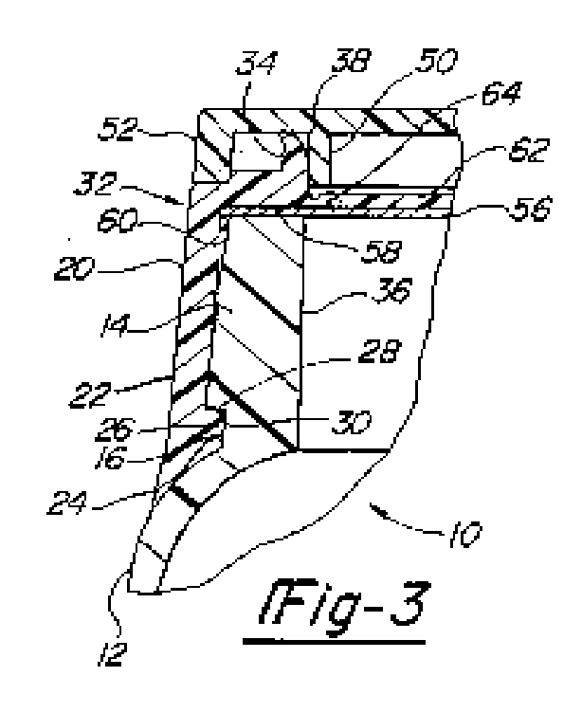

*Section 32 has an inner upwardly extending nozzle or funnel 34 which extends [circumferentially][1] above and substantially in vertical alignment with the inner surface 36 of container neck 14. The nozzle bevels outwardly towards its upper end as shown at 38. This functions to improve its funnel like effect which assists in dispensing material from within. In addition it serves to facilitate closing of the lid 40. Lid 40 is shown to be pivotally mounted on posts 42 and 44 in the manner shown in U.S. Pat. No. 4,682,702. As disclosed in the latter patent posts 42 and 44 have abutments which snap into recesses in the channels 46 and 48 to provide the hinge action. Other forms of hinges may be used such as a living hinge in which the base, the lid and the hinge are integrally molded. The lid has an inner depending circular rim 50 which is sized to closely fit the nozzle 34 and forms therewith the means for closing the container. The lid also has a peripheral rim 52 which frictionally engages rim 54 on base 20 sufficiently tightly to form a retaining means for retaining the lid in closed position.*

*A disc like impervious foil liner-seal 56 extends substantially completely across the inner chamber formed by skirt 22 immediately adjacent the lower [planar][2] surface 58 of upper section 32 of base 22 and extends across and closes spout or funnel 34. A peripheral inner flange or bead 60 is spaced downwardly from surface 58 a distance such that when disc seal 56 is placed within the peripheral recess thus formed between flange 60 and surface 58 the disc will be retained in this position. Further skirt 22 is dimensioned such that when the skirt is forced into recess 16, the disc will be firmly in contact with surface 58 and the lip of neck 14.*

1. It will be seen that item 34 is variously described as a *“nozzle or funnel”* and as a *“spout or funnel”*. It is said to bevel outwardly towards its upper end. It is also said that this outward bevelling improves a funnel-like effect when assists in dispensing material from within, although if it does bevel outward towards its upper end this would seem more likely to me to improve a funnel-like effect when filling the container rather than when emptying it.
2. Figure 5 of Gach 2 looks like this:



1. This is described as follows:

*FIG. 5 shows a second form which the invention may take. In this instance the disc 67 is of the same construction as disc 62 except that it is not joined to base section 20. Instead it rests on and is supported by a liner 68 of the same general form and construction as liner 56. In this case however, the liner must be strong enough to support disc 67 and its associated pull ring. The liner may be provided with a circumferential score line 70 to facilitate tearing at the edge of the inner surface of the funnel. The disc 67 approaches closely to the spout thus insuring that substantially all the foil will be removed. A bead 60 holds the foil liner in position until assembly with the container.*

1. The Defendant submitted that Figure 5 is showing the same as Figures 1-4, with the following difference. Instead of joining the disc 67 to the base section 20 via breakable webs 64 (which are shown eg in Gach 2 Figure 2, a plan view in which the pull ring can be seen), the Figure 5 embodiment relies on the foil liner alone to support that disc and its associated pull ring. Hence there is a tiny gap to the left and right of the disc 67 and the vertical side wall, just visible in Figure 5. I reproduce Figure 2 of Gach 2 below:

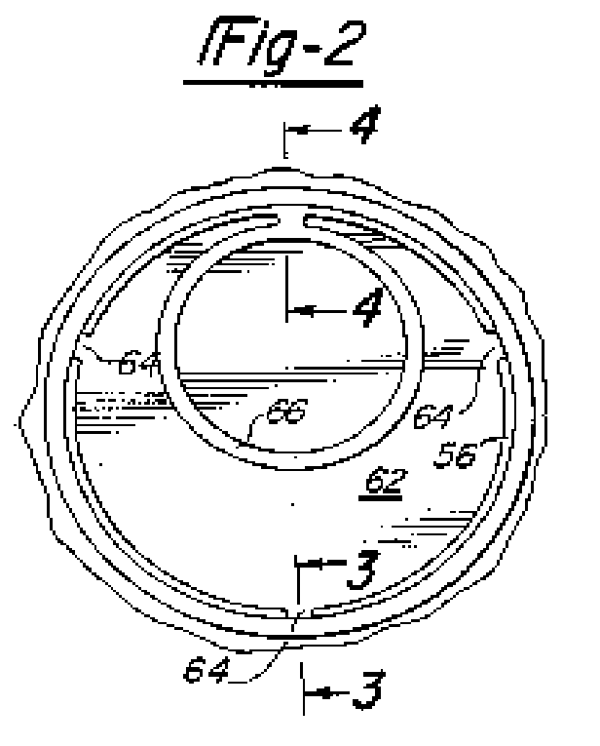

1. I accept the Defendant’s submission as to what Figure 5 shows, but it does not take matters much further as regards the definition of spout. I will need to return to this Figure when considering “frangible region”, below.
2. Having gone through the detailed exercise which both sides urged me to do, and which I have accordingly set out above, it seems to me that this exercise makes very little difference. I do not accept that the spout merely defines an opening, since on that view anything with a hole would have a spout. I do accept that having a spout aids pouring, as mentioned in Gach 2, but that seems to me to be a consequence of a spout being *“a pipe or similar conduit through which water or other similar liquid flows and is discharged”* as opposed to being a mere opening*.* I shall use the dictionary definition, with which both Spreckelsen McGeough and Gach 2 are in my view consistent.

*“Frangible region”*

1. The dictionary definition of “frangible” is “capable of being broken”. Both sides accepted this definition. Instead the dispute was whether the foil itself could form the *“frangible region”* which is part of the integer *“a removable plastics part connected to the spout by means of a frangible region”*. The Claimants submitted that it could and the Defendant said that it could not.
2. Both sides referred to the prior art specifically mentioned in paragraph [0005] of the patent, and in particular to Gach 2 Figure 5. It was not disputed that disc 67 and the nozzle or funnel 34 (unnumbered in Figure 5, but plainly the same as in Figure 3 of Gach 2) could be examples of the removable plastics part and the spout respectively. The point is that in Figure 5, the only thing connecting these two items was the foil liner 68.
3. There is nothing in this integer of the claim which defines any particular type of connection between the removable plastics part and the spout. The closure works by allowing the user to remove the plastics part whilst leaving the spout on the container. The claim achieves this objective by ensuring that the connection between them is frangible, ie breakable. Nothing more is required and there is no reason why a connection consisting only of the foil, as shown in Gach 2 Figure 5, cannot achieve this objective. More specifically there is no reason to suppose that when paragraph [0005] of the patent said that Gach 2 disclosed a closure containing this integer, it meant to say that only the first embodiment in Gach 2 did so and that the second embodiment did not.
4. The Defendant submitted that if the patentee had intended that the foil could itself act as the frangible region, the claim would have been drafted differently. The Claimants replied that this was an example of a *“meticulous verbal analysis”* of the type deprecated in **Virgin** at [5(xi)].
5. I have no doubt it would have been possible to draft the claim differently, as the Defendant submits, but I do not see that this takes the argument any further. The term “frangible region” is wide enough to cover both (a) a series of bridges and a foil, and (b) just a foil. I also consider that there is force in the Claimants’ submission that this part of the Defendant’s argument involves a meticulous verbal analysis.
6. For the above reasons I accept the Claimants’ submission as set out in [38]. That is to say, the foil itself can form the “frangible region”.

*“Peninsula”*

1. This appears as part of the characterising clause, ie “*the leg (14) is mounted such that it applies a force on a peninsula (50) of the removable part.”* The dictionary definition of peninsula is *“a piece of land that is almost an island, being nearly surrounded by water”*. Both sides submitted, and I accept, that this definition is not appropriate in this context.
2. However it proved much more difficult to identify a definition which was appropriate. The Claimants submitted that it meant an isolated portion, or separated part, of the removable part but added that this portion or part was still connected to the rest of that part. The Defendant accepted this so far as it went, but added that a “peninsula” had to protrude from the removable part.
3. The most general teaching about the peninsula appears to be the passage from paragraph [0020] of the patent which I have highlighted above, and even this is only put forward as being generally true of the various embodiments discussed in that section rather than as regards the invention as a whole. The context is that the closure operates by the user pulling on the pulling device (eg a ring pull), which has a leg connecting to the removable plastics part. This act of pulling is what tears the foil but it requires the user to exert some force. The patent teaches at [0013] that the required pulling force can be reduced by limiting *“the length of an arc of the frangible region over which an initial pulling force is dissipated when the tear is being initiated”.* This is done by using “structures” which are referred to as peninsulas. The point about the peninsula structure is that it *“results in a limited arc of the frangible region to which a pulling force created by the pulling device is applied and thereby increases a tearing pressure on the foil”*: see [0020].
4. Figure 2 shows a top plan of the first embodiment, and item 50 is said to be the peninsula in this embodiment. The Defendant produced a coloured diagram during trial, which I have corrected slightly following the submissions made at trial and which I annex hereto at Annex 2. The pink item (numbered 50 in the original) is described at [0047] as the peninsula. In particular it is *“defined at the periphery of the disc 10 by means of two spaced notches 52 that project in the ring 44 to provide a peninsula 50 sufficient deep to house the bases 54 of both legs 14”*. In this context, the disc 10 is the removable plastics part of the claim. One can see how the peninsula 50 might be said to protrude from the ring 44 of the disc 10.
5. Figure 3 refers to the second embodiment. Paragraph [0051] says that the peninsula 50 *“projects from the periphery of the ring 44 into a corresponding indentation 64 in the spout 6”*. This also refers to the idea of projection, although item 50 is not marked in the Figure.
6. Figure 4 refers to the third embodiment. This has a slit 70 in the disc. Item 50 is again not marked, but its location can be deduced from paragraphs [0054]-[0055], as follows:

*[0054] A slit 70 extends from an edge of the disc just beyond the enlarged portion 38 of the land 34. The slit passes off centre, skirting the end of the land portion 40 and terminates short of an opposite edge of the disc 10. The slit 70 is provided with an enlarged circular end 72 in order to reduce the risk of the removable part 10 being severed in two during removal. Such breakage could occur if the disc 10 is broken at a neck between an end 72 of the slit across to the frangible region 30. The land 34 has a further enlarged portion 74 in this neck area opposite the end 72 of the slit 70 to prevent the removable part 10 breaking at this point. Weak bridges 76 cross the slit 70 at its open end adjacent the corner-shaped peninsula 50 on which the legs 14 are mounted and at an intermediate point. These bridges 76 are to enable the disc to be moulded and are sufficiently fine to sever when subjected to minimal pulling force.*

*[0055] The slit 70 effectively divides the plate 10 into a U shape with a pull ring attached solely and securely to one limb that is the peninsula 50. Due to the open slit 70, the pulling force applied by pulling on the pull ring 12 is concentrated solely on the limb to which it is attached. The foil 8 will initially stretch in the region attached to the enlarged land portion 38. The presence of the slit 70 reduces the arc of the frangible region over which the force is applied. The pulling device needs to be mounted as close as practicable to the peninsula corner at the end of the slit to ensure that the pulling force is applied over as small an area as possible so that a tearing threshold pressure is achieved with minimal exertion in order to initiate the tear. As the legs 14 are mounted on a readily free-able corner of the plate 10 next to the slit 70, the effect is to cause the user to pull, not directly upwards, but at an angle skewed towards the intended direction of propagation of the tear. This further reduces the area of the foil that is subjected to the pulling force. Using two legs allows the leg 14 closest to the slit 70 to define the centre of the arc.*

1. From the above it is apparent that the patent is using the term peninsula to identify the corner of the disc 10 which is at the end of the slit 70 where the legs 14 are mounted. I annex (at Annex 3) a marked-up version of Figure 5 showing in red where the Claimants submitted the peninsula must be. This submission was not disputed by the Defendant and I accept it. It will be apparent that the patent’s description of it as being a corner is correct, and that it does not project or protrude any more than any other corner.
2. I am not surprised that the patentee found it difficult to find a single word which accurately and concisely described all of these arrangements in which the term “peninsula” is used. Neither side suggested any better word at trial. However I do not accept that the claim is so ambiguous that infringement cannot be established. I believe that the Claimants are closer to the true meaning when they say that the peninsula must be some isolated portion of the removable part. It does not have to protrude from the removable part, as the Defendant submits, but the peninsula has to be distinguished from the rest of the removable part in some way (eg by protrusion, or by being a corner). It has to be distinguished from the rest of the removable part in order in order to form a structure which *“results in a limited arc of the frangible region to which a pulling force created by the pulling device is applied and thereby increases a tearing pressure on the foil”*. All of the Figures are consistent with this interpretation.

*Claim 14*

1. The above issues all arose in relation to both claims 1 and 14, but there is one additional issue on claim 14. The characterising clause requires there to be a *“device mounted … on the spout such that it applies a pushing force to a peninsula at the periphery of the removable part 10”*. As the Defendant submitted, there is not much in the patent about devices applying pushing forces as opposed to pulling forces. However as explained in paragraph [0059] of the patent, there might be a pull ring or tab mounted on a pivoting point, or there could also be a tab mounted directly to the plastics part 10.

**Infringement**

*Claim 1*

1. As part of their case the Claimants prepared an annotated diagram of the Mark 1 version of the Defendant’s product, which I annex at Annex 4. The Defendant also supplied a markup of the same product which is at Annex 5. I will refer to the Claimants’ markup for convenience.
2. I was also supplied with physical samples of Marks 1 to 8. Neither side that anything turned on the differences between any of the 8 versions. I agree.

*Do the Defendant’s products have a spout?*

1. One point which does not emerge from the markup drawings is that the Defendant’s closure is essentially flat. I was not told what its precise height is but it appears to be less than 1mm. In practice, the user pulls the ring pull in the centre; this tears the foil in the region marked “V-shaped slot defining peninsula”; as the user continues to pull, the inner ring lifts up and continues to tear the foil; and after the inner ring has been lifted all the way round then the combination of the ring pull, inner ring, and foil all lift off together leaving the outer ring.
2. In my judgment this arrangement cannot be described as being *“a pipe or similar conduit through which water or other similar liquid flows and is discharged”.* I also accept the Defendant’s submission that the height of this closure is *de minimis.*  Hence this integer is not present.

*Is the removable plastics part connected to the spout by means of a frangible region?*

1. In their diagram, the Claimants have identified the area between inner and outer ring as being the frangible region.
2. The Defence had repeatedly made the point that the inner ring of its product was *“wholly severed”* from the outer ring during manufacture: see eg paragraphs [2.11], [3.1], [3.4], [4] which express this in slightly different terms. This evidence was supported by a Statement of Truth, which following the case management conference was co-signed by Se Hwang Wei, Chief Executive Officer of Seal & Pack Limited. As I have said there was no application to cross-examine Mr Wei despite the express comments made by the Court at the case management conference. I have no reason to reject the Defendant’s evidence and I accept it. Hence there is nothing directly linking the inner and outer rings (eg a bridge of material) which could satisfy this integer.
3. As I have already foreshadowed, the Claimants’ alternative argument was that the foil itself could qualify as the relevant “frangible region”. The Defendant complained that this point had not been pleaded. The Defendant recognised that arguments of construction need not always be pleaded in this Court (see **Glass v Freyssinet** [2015] EWHC 2972 (IPEC) at [19]-[21]) but submitted that this was not just a new argument on construction. On the contrary, the Defendant complained that the Claimants were instead seeking to rely on a completely different part of the alleged infringing product as corresponding to the integer in question.
4. However, the Defendant did not allege any deliberate concealment or identify any significant prejudice caused by a failure to plead this argument: see **Glass** at [21]. Moreover, the Claimants pointed out that they had mentioned the aluminium foil in this context in their reply at paragraph [9] (see eg subparas [3.1]-[3.3] thereof). It seems to me that the Claimants had thereby done enough to bring this argument to the attention of the Defendant, and that both sides were perfectly able to deal with it at trial. I therefore allow the Claimants to rely on this argument; and having done so, it follows from my conclusions on construction that the Defendant’s products satisfy this integer.

*Do the Defendant’s products have a peninsula?*

1. I have set out my interpretation of “peninsula” at [51] above. I accept that the Defendant’s products have a “pulling device” (the pull ring) and that this is connected to the “removable plastics part” (the inner ring) by means of a leg (the strip of plastic which links the two). The area indicated by the Claimants is not a protrusion, but it is at least a corner. Indeed it is not dissimilar to the third embodiment shown in the Patent. Moreover this corner forms a structure which *“results in a limited arc of the frangible region to which a pulling force created by the pulling device is applied and thereby increases a tearing pressure on the foil”*. In my judgment the Defendant’s products satisfy this integer as I have construed it.

*Claim 14*

1. Since there is no spout, infringement of this claim does not arise. However whatever one calls the spout, there is also nothing mounted thereon such that it applies a pushing force to anything. As the Defendant says, the user only ever applies pulling forces to its closures and the sort of arrangements envisaged in paragraphs [0059]-[0060] of the patent are not present here. Claim 14 is not infringed for this further reason either.

**Conclusion**

1. None of the Defendant’s closures falls within the scope of either claim 1 or claim 14. It follows that none of the Defendant’s acts have infringed the patent.

**Annex 1**





**Annex 2**

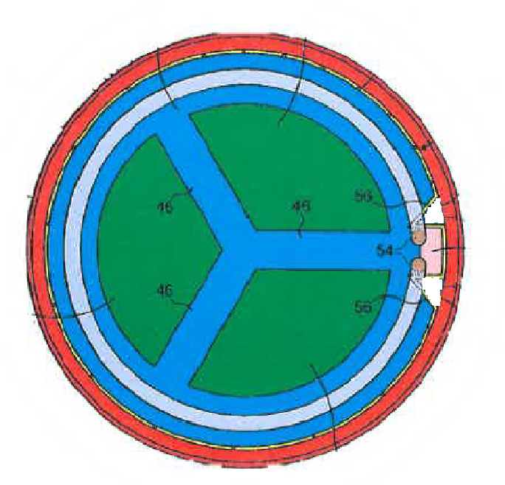

**Annex 3**

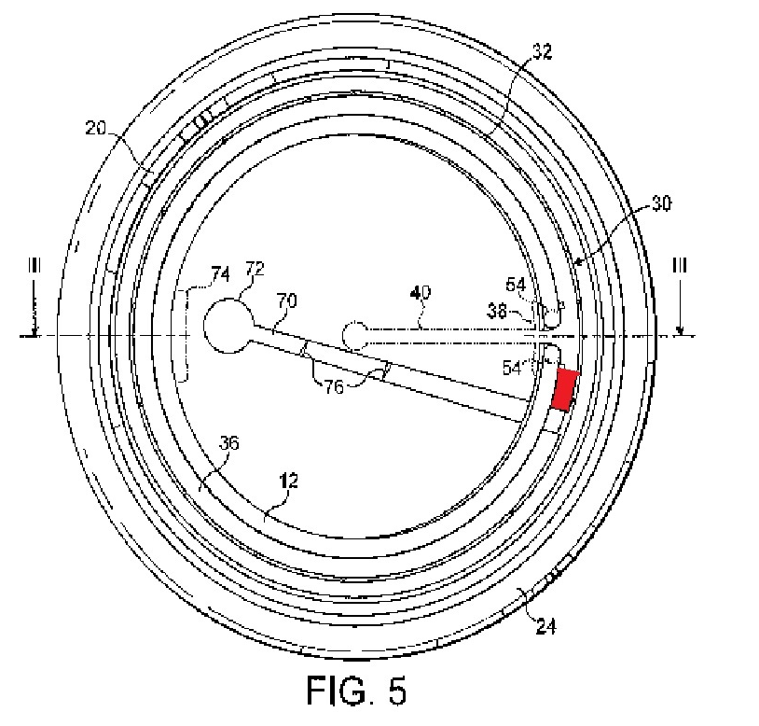

**Annex 4**

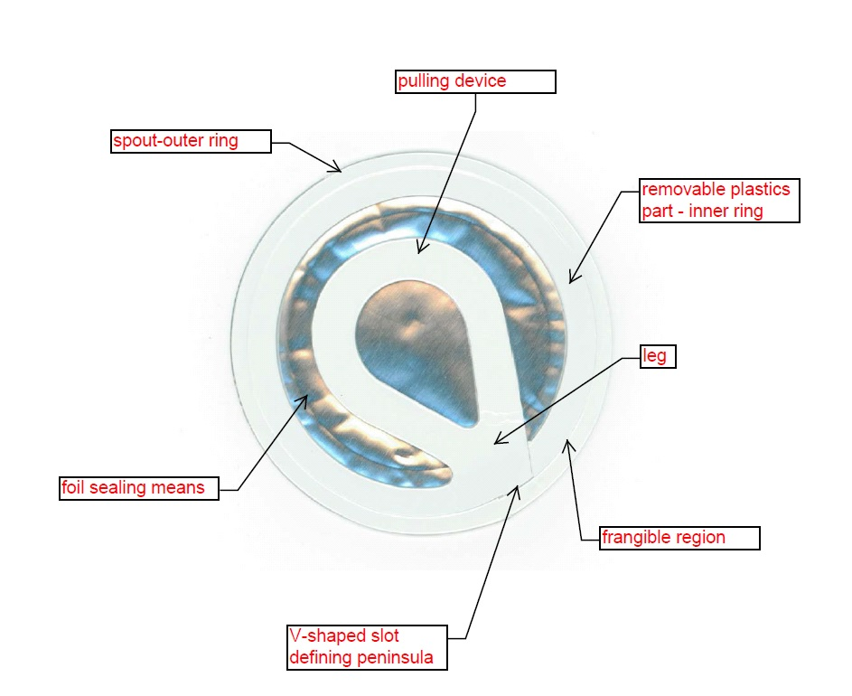

**Annex 5**

**Inner Ring Outer Ring Pull Tab** **B**

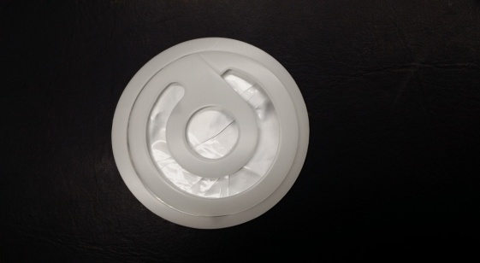

1. The original says *“circumferenitally”.*
2. The original says *“plannar”.*